Academic Affairs Assessment of Student Learning
Report for Academic Year __2020__-__2021

Department/Program: Education (Initial Programs)
Assessment Coordinator’s Name: Dr. Stephanie Burdette
Assessment Coordinator’s Email Address: Stephanie.burdette@wvsu.edu

- Which learning outcomes did you measure this past year?
The Education Department measures every outcome every year as part of our assessment work for program approval and accreditation through the state of West Virginia and various national Specialized Professional Associations (as recognized by CAEP).

PLOs APPROVED by the Education Department in June 2018
1. Demonstrate knowledge of chosen content field(s).
2. Teach units and lessons aligned with national and state standards that address the
learning needs of all students.
3. Integrate technology and twenty-first century learning tools and skills in their own
teaching as well as in the learning processes of their students.
4. Exhibit behaviors of a professional teacher congruent with the conceptual
framework which includes Dispositions and Teacher as a Human Developer.
- (a) Maintain effective learning communities that value diverse abilities and talents and facilitate respect for all and (b) Make connections in the school and community by communicating effectively with parents and other community members to promote student learning.
Note: new PLOs were adopted in August 2021 and will be reflected in future reports. Additionally, extensive programmatic review/revisions began with Spring 2021 planning and implementation beginning (on a gradual basis) beginning in Fall 2021 piloting

2. In which course(s) were assessments conducted?
Educ 200, 227, 300, 316, 331, 423/ 426, and student teaching*
*Assessments are conducted over the entire course of the program. Only the courses noted above contain assessments that are used for CAEP accreditation purposes
3. How did you assess the selected program learning outcomes?

Learning Outcome (PLO) | Where  Measured | Which  Measure Used | Rationale
1. Content Knowledge | At the end of the program | Praxis II Exam* | These nationally normed tests can help the program compare our candidates with other candidates in the same fields.
2. Planning and Teaching | Educ 316 – first methods course  Educ 426 | CAPT rubric –  Candidate Ability to Plan and Teach | Provides an early assessment of planning, teaching and DBDM
 | Educ 227 – End of Sophomore year course | UDL Rubric | Provides an assessment of ability to plan to adapt instruction for students with learning needs
 | Educ 331 – After 316, but before student teaching | WVTPA with  students with disabilities* | Provides an opportunity to improve the achievement of a student or students with disabilities.
 | SCOPE | SCOPE Rubric* | Provides evidence that the candidate has had sufficient positive experiences prior to student teaching so that they are ready to teach
 | Student Teaching | STAR and WVTPA  Rubrics* | Performance assessments to measure readiness for professional teaching career.
3. Technology | Educ 300 – The same semester as 316 ( the first teaching methods course) | Technology  Integration  Rubric* | Provides a measure of candidates ability to plan a unit in which technology forms an important part
 | SCOPE | SCOPE*  portfolio presentation, evaluated by at least two  faculty members using a rubric. | Assesses the degree to which candidates have used technology to enhance student learning prior to student teaching.
 | Student Teaching | STAR Rubric | Assesses technology use in student teaching
4.  Dispositions | Educ 200 | Philosophy of  Education  Rubric* | Provides an early assessment of Philosophy of Education – which reflects beliefs about how individuals learn, and these beliefs are dispositions.
 | Educ 200, 316, 426, student teaching | Disposition Rubric*  (Beginning Fall 2021-Educational Disposition Assessment (EDA) | Rubric completed 5 times during a candidate’s college career: self-assessment in 200; professor complete in 316, 423 or 426; and during student teaching by the University Supervisor and a self-assessment.  Educational Disposition Assessment (EDA), proprietary assessment which addresses professional dispositions relevant to pre-professional educators.
5. Diversity and Community | Educ 426 | CAPT | Part of the CAPT relates to management
 | Educ 426 | Reflection on  Management | Reflection on what actions during teaching related to aspects of management.
 | Student Teaching | STAR* | Some of the elements of the STAR relate to management.
 | Educ 426 | Rubric is used to score a family connections artifact | Provides a measure of candidates’  ability to design family communications  (This activity is being revamped over the course of the Spring 2020 semester and may be placed within another course).
 | Student Teaching | STAR* | One of the elements of the STAR relate to family communications.
*data used for the purpose of this reporting
4.How many students were included in the assessment(s) of each PLO in a course?

All student enrolled in the pertinent course were included in the assessment process.

5.How were students selected to participate in the assessment of each outcome (Helpful details might include- whether this assessment represents all students, a sample of students in a class, or a sample of students across sections)?

All students were a part of the process. We do not sample. Data collection efforts during the Spring 2020 and Fall 2020 semesters were greatly compromised due to the impact of Covid on instruction typically delivered in the classroom as well as field experience options that had to be modified due to restrictions on public school visitation.

- In general, describe how each assessment tool (measure) was constructed (i.e. in-house, national, adapted).

Assessment Tool | How it was constructed
Praxis II Exam* | Nationally normed tests constructed by ETS (ets.org).
STAR* | Student Teaching Assessment Record: In-house, based on the WV Professional Teaching Standards. It has been revised several times. The current iteration is the Fall 2013 version.
WVTPA* | The West Virginia Teacher Performance Assessment (TPA) is an instrument collaboratively developed in conjunction with WV’s TEAC (Teacher Education Advisory Committee). The assessment t is completed by all candidates during the culminating internship/student teaching experience.
SCOPE Rubric* | In-house. It has been revised several times. The current iteration is the Fall 2013 version with a minor change in Fall 2016 to improve the scoring of the Presentation area and bring it in line with the Oral Communications VALUE rubric. The instrument underwent a series of reliability/validity measures in December 2019 with revisions being incorporated during the Spring 2020 semester.
CAPT rubric – Candidate Ability to Plan and Teach | In-house. It has been revised several times. The current iteration is the Fall 2019 version.
Ed 300 Technology Integration Rubric* | In-house. It has been revised three times. The current version is the Fall 2015 revision.
UDL Rubric | In-house. It was developed in 2011 and revised for Fall 2016. Used in EDUC 227
WVSU Education Candidate Dispositions Rubric* | The instrument was originally created at the University of Connecticut. WVSU received permission to adapt the rubric during the Fall 2019 term. It is complete in 316, 423 or 426; and during student teaching by the University Supervisor and a self-assessment.
Admission to Teacher Education | Admission to Teacher Education Program document. Collected at end of pre-professional phase. Created in-house.
Ed 426 Rubric scores a family communication artifact and reflection. | In-house. Developed in Fall 2013 and revised in Fall 2015.This instruction was not utilized in Fall 219 as we reviewed the program needs during this transitional year. We obtained data from another course but have recognized the need to resume collection in Ed 426 in spring 2020.

*data used for the purpose of this reporting
7.Who analyzed results and how were they analyzed
The WVSU Education Department works as a unit to implement and analyze data. Dr. Stephanie Burdette (WVSU Assessment Coordinator) monitors the collections and uploading of data to LiveText. After such time, information is extracted using Excel and distributed to
the department for ongoing, continuous review of programmatic endeavors. Select data sets are examined over time to ascertain trends. Beginning with the Fall 2019 semester, the department has opted to examine data each semester as opposed to yearly, and this practice has been maintained.

8.Provide a summary of the results/conclusions from the assessment of each measured Program Learning Outcome. Report scores for this assessment, as well as students’ strengths and weaknesses relative to this learning outcome.

PLO 1: Demonstrate knowledge of chosen content field(s)
PRAXIS

Praxis II tests measure the academic skills and subject-specific content knowledge needed for teaching. The tests are taken by individuals entering the teaching profession as part of the certification process required by many states and professional licensing organizations. This instrument is administered by the Educational Testing Service.

These assessments allow West Virginia educators to demonstrate their knowledge of content, pedagogy and instructional skills for the classroom. These tests are important components of West Virginia's licensure and certification process and include:
- Praxis Core Academic Skills for Educators (Core) — comprehensive assessments that measure the skills and content knowledge of candidates entering teacher preparation programs*
- Praxis Subject Assessments — tests that measure general and subject-specific content knowledge that you need for beginning teaching
*Core test results are used as a component of the admission to candidacy process. Those results are not a component of the licensure process. Additionally, increased admission rates due to WVDE SAT/ACT exemption and the success of Praxis core support courses have resulted in higher passage rates. Our reporting for university purposes will focus upon licensure/professional phase Praxis data.

The charts below denote the 1-year pass rate for Praxis (subject matter content) across all education programs at WVSU for September 2020-August 2021 with data displayed by semester (with Spring 2019 data included within chart one). Post-August 2021 data is being compiled and will be available for reporting at a later date.

Education Licensure Pass Rates Spring/Fall 2020
Program | # of WVSU Program Completers | # of WVSU Test Takers/ Test Attempts | % WVSU Test Takers Passing on First Attempt (provided by ETS) | % WVSU Test Takers Passing at the State Cut Score (provided by ETS)
Art Pre-K-Adult | 1 | 1/1 | 100% | 100%
Biology 9-Adult | 0
Business 5-Adult | 1 | 1/1 | 100% | 100%
Chemistry 9-Adult | 1 | 1/1 | 100% | 100%
Elementary Education K-6 | 26
Reading |  | 26/40 | 46% | 100%
Math |  | 26/29 | 88% | 100%
Social Studies |  | 26/67 | 0% | 100%
Science |  | 26/54 | 0% | 100%
Teaching Reading |  | 26/34 | 69% | 100%
English 5-9 | 0
English 5-Adult | 4 | 5/5 | 100% | 100%
General Science 5-Adult | 0
Mathematics 5-9 | 0 | 1/1 | 100% | 100%
Mathematics 5-Adult | 1 | 1/1 | 100% | 100%
Multi-Categorical K-6 or 5-Adult | 0
Music Pre-K-Adult | 3 | 3/3 | 100% | 100%
Reading K-6 or 5-Adult | 0
Social Studies 5-9 | 0
Social Studies 5-Adult | 3 | 3/3 | 100% | 100%
Wellness Pre-K-Adult | 2 | 2/4 | 50% | 50%
PLT | 43 | 38/39 | 97% | 97%

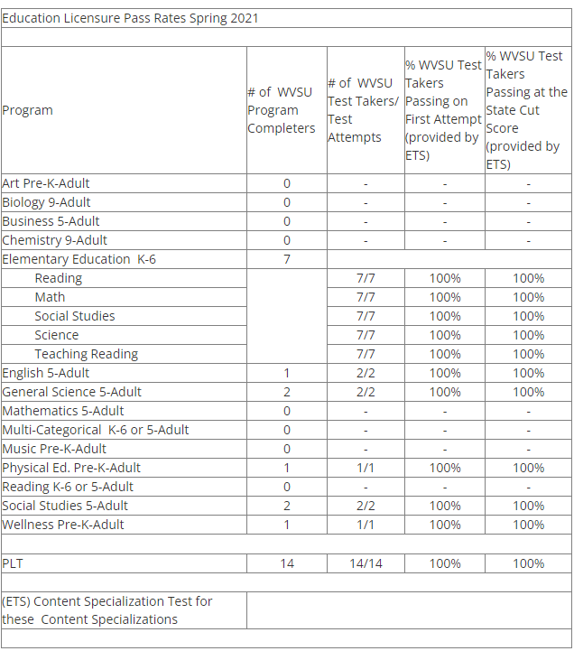

A comparison of Praxis data between Spring 2019/Fall 2020 and Spring 2021 has revealed that our elementary education candidates have improved in their efforts to successfully attain a passing score on subcategories of reading, social studies and science which have proven to be problematic in the past. These reported scores are for content specialization tests undertaken during the professional phase of the program. Passage difficulties were not doubt compounded by issues related to Covid and the closures/modification of content delivery in courses.

There was a 3% increase in the percentage of candidates who successfully passed the PLT on their first attempt. Yet a decline of 15% was noted for secondary level majors on the same assessment. It should be noted that there is a significantly lower enrollment within secondary programs thus any decline appears to be statistically significant. Increased enrollment in EDU 200 for Fall 2021 signals a potential upturn in program numbers.

PLO 2: Teach units and lessons aligned with national and state standards that address the learning needs of all students.

WVTPA: The West Virginia Teacher Performance Assessment (TPA) is a collaboratively developed assessment that is completed by all candidates during the culminating internship/student teaching experience. The TPA requires that teacher candidates draw on pedagogical and content pedagogical knowledge to plan and deliver instruction that builds on each student’s strengths, needs, and prior experiences. Through this performance assessment, teacher candidates provide credible evidence of student impact.
The TPA includes seven performance tasks that have been identified from research and best practice as fundamental to improving student learning. Professional standards and rubrics define and frame performance on each teaching process. Candidates are required to plan and teach a unit (consisting of a minimum of 3-5 lessons). Before beginning to teach the unit, candidates identify and describe contextual factors, formulate learning goals based on state and national content standards and prior research-based decisions on student performance, develop an assessment plan to measure student performance before (pre-assessment), during (formative assessment) and after (post-assessment) instruction, and design an instructional plan. During instruction, candidates will videotape and analyze teaching episodes. After teaching the unit, candidates will analyze student learning, report on student progress toward the learning goals, and reflect upon and evaluate teaching as related to student learning.
The TPA is evaluated by university-based faculty. The four-point rating scale on each rubric reflects the same descriptors you will see as a beginning teacher in West Virginia. The scoring on the TPA uses the same scale used for evaluating in-service teachers in West Virginia.

Candidates must score “Emerging” or “2 points” on each descriptor in each rubric in order to satisfactorily complete the TPA. Candidates who score an “Unsatisfactory” or “1 point” on any item will be required to remediate and/or re-do the TPA. Additionally, in cases where the candidate left out a Task component of the TPA, the judgment of the faculty will determine how the candidate is to remediate the issue. Your performance on the TPA will be used to provide evidence for program completion. In addition, the completed document can be used to showcase your qualifications as an applicant for a teaching position.
Candidates include tables, charts, graphs, assessment instruments, lesson plans, and samples of student work and a short video from lessons that you taught. Each of these are a required part of the TPA. If one or more sections are omitted, you will be required to remediate and re-do the TPA. Any references to another person’s ideas or material in your narrative must include a citation for each source at the end of each task. Any standard form for references may be used; however, the American Psychological Association (APA) style is recommended.

The outline for your Teacher Performance Assessment is as follows:
TASK 1: Contextual Factors
TASK 2: Standards and Goals
TASK 3: Assessment Plan
TASK 4: Design for Instruction
TASK 5: Implementation and Reflection on Daily Instruction
TASK 6: Impact on Student Learning
TASK 7: Reflection and Self-Evaluation

The WVTPA has been administered with to students at WVSU since it formally replaced the Action Research Project as the culminating assessment structured to measure a candidate’s performance within the classroom. Due to Covid-related school closures, Spring 2020 candidates were unable to complete the assessment within their placements. The WVDE dispensed authority to the individual universities to proceed as they deemed necessary regarding the time requirements and data collection typically associated with course completion. Fall 2020 was a transition for candidates back into the classroom for observation/teaching with there being gradual increases in the number of candidates permitted into the schools during Spring 2021 and Fall 2021.

WVTPA data was collected at the culmination of the Fall 2020 semester (see chart above) for the 18 individuals who were completing their residency/student teaching. 5% of candidates were found to be unsatisfactory for the criteria associated with use of standards as well as use of learning goals. An additional 11% were found to be unsatisfactory in regarding to aligning instruction with learning goals. The WVTPA guidelines require students to score no lower than emerging on any element. The individuals who scored at unsatisfactory were required to resubmit those sections of their project and attain a minimal score of emerging. 100% of resubmissions received a passing score.

WVTPA data from Spring 2021 included a data pool of n=12. There were no candidates who scored at the unsatisfactory level. There was a notable increase in the number of candidates scoring at the emerging level on criteria 2.2 Learning Goals. Candidates improved performance on criteria 3.1 Alignment with Learning Goals with all scoring being registered at the distinguished and accomplished level.

Fall 2021 WVTPA data consisted of n=19 which is a significantly larger data set that had been reported in previous semesters. Again, there were no candidates with unsatisfactory performance. Overall performance was more solidly within the distributed across the top three performance criteria.

PLO 3: Integrate technology and twenty-first century learning tools and skills in their own teaching as well as in the learning processes of their students.

Two assessment instruments were utilized to collect data associated with technology Integration, the SCOPE as well as the EDUC 300 Unit Plan Rubric. Senior Capstone Oral Presentation E-Portfolio (SCOPE) is a presentation of an E-Portfolio to both Education Faculty Member and Content Faculty Member during Educ 426 (Senior Capstone Phase). The EDUC 300 Unit Plan requires students to submit a technology rich unit plan in their content area, which is scored for quality of technology integration. The rubric for EDUC 300 was newly revised in Spring 2020 to reflect new ISTE standards as well as redesigned course expectations.

We reproduced (below) the elements of the rubric that are related to Technology Integration and Student Use of Technology from the Educ 300 Technology Integration Rubric. These two elements are the main elements that relate to Candidate accomplishment of PLO 3, Integrating Technology in Teaching and Learning.

EDUC 300 Rubric Elements for Technology Integration

Exceeds Standard (3.000 pts) | Meets Standard (2.000 pts) | Does Not Meet Standard (0.000 pt)

Access to Technology (1.000, 4.5%)  WV-WVSU-EDD.4.1 WV-WVSU-GV.5 | 7.1 When technology was used, the lesson provided for access to ALL students with a written plan for distribution or access included. | 7.1 When technology was used, the lesson provided for access to ALL students. | 7.1 When technology was used, the lesson did not address how to provide access to ALL students.
Alignment with WV Next Generation and ISTE Standards (1.000, 4.5%)  WV-WVSU-EDD.4.1 WV-WVSU-GV.5 | 7.2 Aligned with WV Next Generation Standards and National Technology Standards. | 7.2 Aligned with WV Next Generation Standards regarding technology. | 7.2 The lesson was not aligned with WV Next Generation Standards regarding technology.
Developmentally Appropriate Technology (1.000, 4.5%)  WV-WVSU-EDD.4.1 WV-WVSU-GV.5 | 7.3 Technology usage was developmentally appropriate and described. | 7.3 Technology usage was developmentally appropriate. | 7.3 Technology usage was not developmentally appropriate.
Technology & Expectations (1.000, 4.5%)  WV-WVSU-EDD.4.1 WV-WVSU-GV.5 | 7.4 Technology usage reflected district and national ISTE expectations. | 7.4 Technology usage only provided functional improvement. | 7.4 Technology usage acted as a replacement, with no functional improvement.

Data displayed below from the newly redesigned EDUC 300 rubric, illustrates that during the Spring 2020 semester, 100% of students attained exceeds standards on half of the criteria associated with PLO 3. 97% of students attained exceeds standards on the criteria associated with developmentally appropriate technology with 75% attaining this level on the access to technology criteria. Then finally, 52% attained this performance level for criteria associated with student’s ability to align activities with national standards. The number of enrolled students for this course was 36 during the Spring 2020 term.

The data in the table below denotes the performance of students in EDUC 300 during the Fall 2020 semester. 100% of students scored at the exceeds standards level on all the identified criteria. The total enrollment for the course was 7 students.

The Spring 2021 data for Edu 300 (below) was somewhat similar to data from previous semesters. However, it should be noted that there were two students who were scored as not meeting the standard for their ability to align their activities from their unit with WV State and ISTE Standards. The course instructor has implemented a mid-semester review of the unit to provide students with feedback/opportunity for revision. This feedback will impact performance as measured on the final collection of data.

Fall 2021 data (see chart below) for EDU 300 Technology Rubric consisted of data from two sections of the course. Again, the data revealed a similar finding as that of Spring 2021. Five candidates were scored as ‘does not meet standard’ for the criteria associated with aligning content with state and national technology standards.

SCOPE

The department also examined the technology results from the SCOPE assessment, which is a pre-student teaching assessment. The SCOPE assessment provides evidence of meeting many program outcomes. Due to Covid-related school closures, Spring 2020 candidates were unable to complete the assessment within their placements. The WVDE dispensed authority to the individual universities to proceed as they deemed necessary regarding the time requirements and data collection typically associated with course completion. SCOPE data collection resumed in Fall 2020 and has continued through the Fall 2021 semester.

Assessment of Artifact on Technology

 | Distinguished = 4 | Accomplished = 3 | Emerging = 2 | Unsatisfactory = 1
Technology  WVPTS 1B, PLO 3 | Both Candidate and students using 21st Century technology, and integration of technology has merit in terms of improving student achievement. | Both Candidate and students are using 21 Century technology. | Candidate demonstrates knowledge of 21st Century limited to one type of technology (example PPT), or limited to candidate use of technology. | Candidate does not demonstrate knowledge of 21st Century technology use in design of this lesson.
Data Based  Decision  WVPTS 1E, 3E, PLO 2 | Candidate demonstrates exceptionally thoughtful reaction with evidence of considerable reflection. Supporting points are drawn from the student data from multiple data sources and teaching experiences. Reflection & future plans show clear understanding of students’ developmental stages and learning needs. | Candidate identifies students’ needs. Reflective statements refer to student data. Includes reflections on strengths & weaknesses of instruction. Includes data-based instructional decisions justified based on aggregated and analyzed student data. | Candidate includes reflections on strengths & weaknesses of instruction. Instructional decisions are made, but not justified based on student data. | Candidate demonstrates either no reflection, or shallow reflection, or reflection does not relate to student data, or does not include statement of instructional insight or student need.

We have included bar graphs of the SCOPE scores related to technology for the Fall 2020 semester. There was an n=14 for the terms. Though there was an exemption for Covid-related factors which might inhibit completion of specific tasks, that option was not applicable to factors associated with the technology section of the assessment.

The Fall 2020 data (above) indicates that less than 0% of SCOPE candidates were performing at the Unsatisfactory level regarding their ability to use technology to enhance and extend learning experiences for students as demonstrated during their SCOPE presentation.

Spring 2021 SCOPE data population was n=22 with no candidates preforming at the unsatisfactory level. 15 candidates scores distinguished for technology and 6 candidates were at the distinguished level for data-based decision making with two candidates considered to be emerging for this criterion.

The chart above contains SCOPE data for Fall 2021 which consisted of 12 candidates. A similar data pattern was noted when compared with Spring 2021 results. There were 3 candidates with an emerging performance (with only 1 individual considered emerging on the technology criterion).

PLO 4: Exhibit behaviors of a professional teacher congruent with the conceptual
framework which includes Dispositions and Teacher as a Human Developer.

WVSU Education Candidate Dispositions Rubric

This assessment is completed 5 times; self-assessment in 200; professor completes in 316, 423 or 426; and during student teaching it is completed by the University Supervisor as well as a self-assessment by the candidate. Fall 2019 marked the initial phase of implementation of this instrument. Full implementation was planned for the Spring of 2020. However, the Covid-related closure of WVSU, rendered the collection of data to be compromised, particularly dispositional data that was collected via in class interactions. Normalized data collection resumed during Fall 2020 and continues to present.

The chart below denotes the self-disposition data collected from two sections of EDU 200 from the Fall of 2020. A comparison of these self-reflections denotes a higher percentage of individuals who considered their professional attributes to be on target yet there was relative consistency in the number of candidates who listed their personal attributes to be considered within the exemplary range. As these groups of students’ progress through the program, it will be possible to compare long term dispositional growth.

Spring semesters tend to be the lower enrollment point for entering education students. There were
13 students enrolled in the single course offered during Spring 2021. Students self-assessed themselves at the exemplary, target and emerging categories except for the following criterion (for which 7.69% reported their performance at the unacceptable level): attendance, self-regulation, completes assignments, and engagement.

Fall 2021 marked an increase in enrollment for incoming freshman/transfers majoring in education with two sections of the course being offered with n=41 (though enrollment was higher than the number of students completing the self-assessment. The EDA consists of the following categories:
Collaborates effectively with stakeholders, Cultural and academic diversity, Effective Oral Communication Skill, Written Communication, Positive and enthusiastic attitude, Preparedness in teaching and learning, Professionalism, Self-regulated learner behaviors/takes initiative, Social and emotional intelligence to promote personal and educational goals/stability.
The creators of the assessment have constructed the rubric within LiveText to allow for electronic data entry. The details of each specific sub-element are not specifically labeled within the reporting framework. Therefore, it is necessary to review the instrument (included within the artifacts) to see the specific criteria within each reported criterion category.
The following charts denote students self-reported performance related to select criterion.
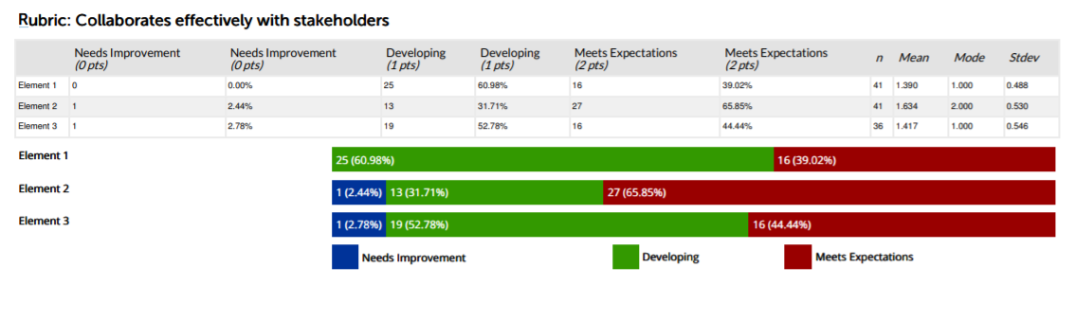
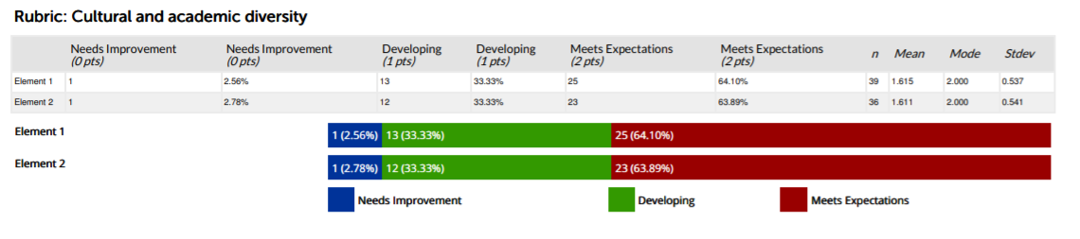
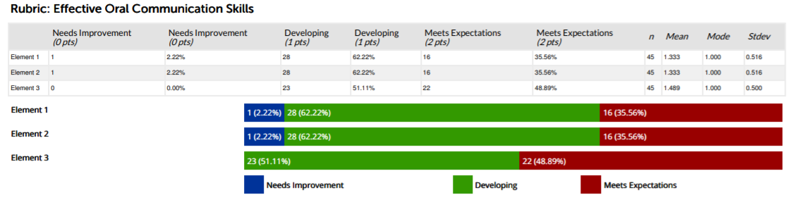
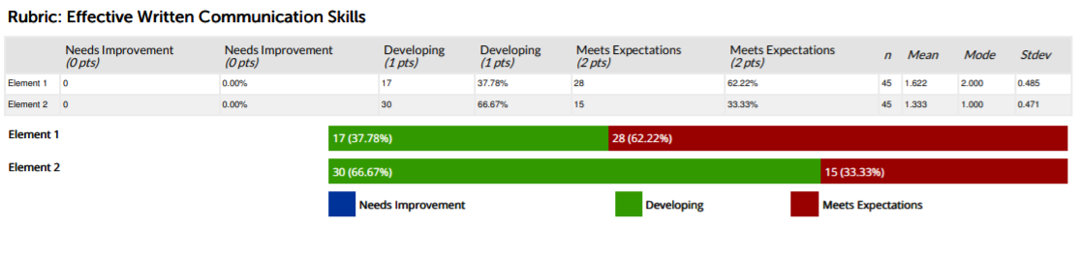
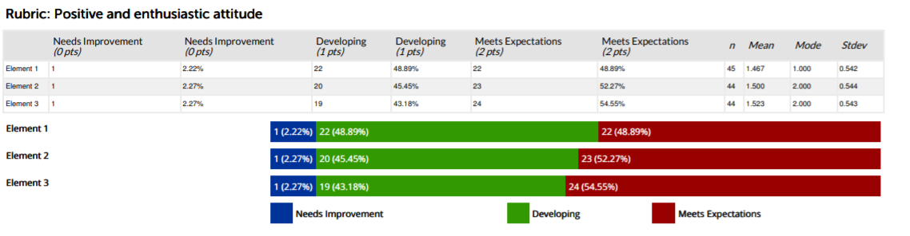
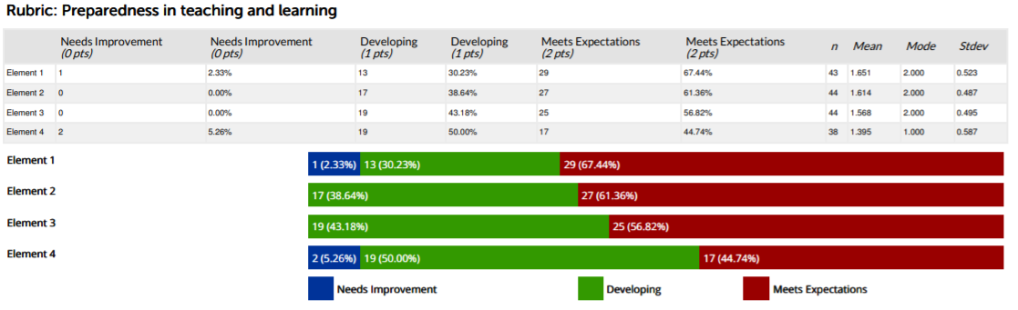

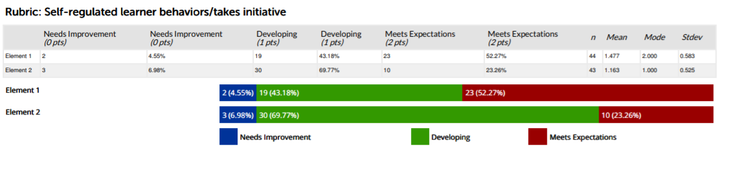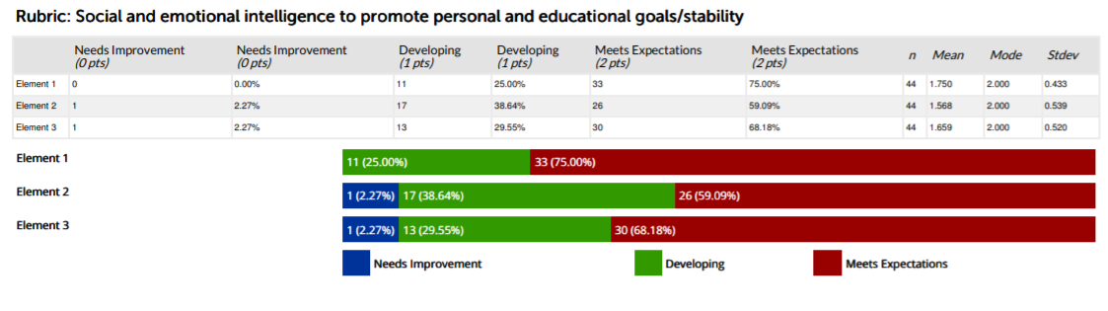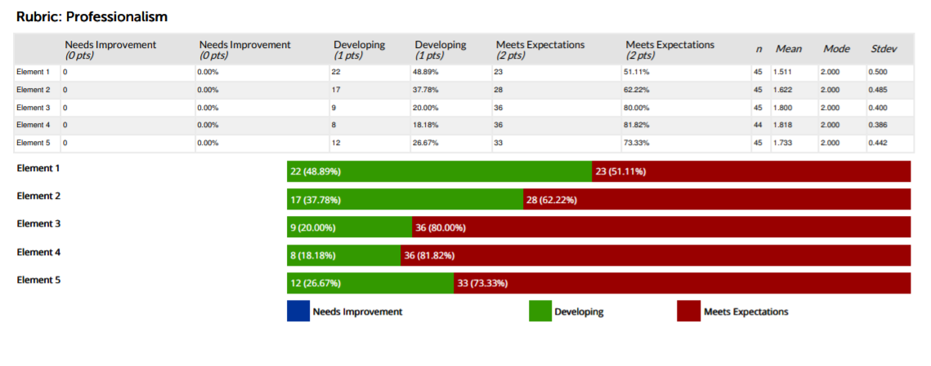
Given that Fall 2021 was the first semester of administering the EDA there is no comparative data. The students who are a part of the Fall 2021 population will tentative be exiting candidates in 7 semesters. At that time, it will be possible to analyze a full spectrum of EDA data.
PLO 5: (a) Maintain effective learning communities that value diverse abilities and talents and facilitate respect for all and (b) Make connections in the school and community by communicating effectively with parents and other community members to promote student learning.

STAR
Student Teacher Assessment Record (STAR) assesses multiple aspects of teaching and professional behavior as well as content knowledge. This assessment is conducted during student teaching – the Senior Capstone Phase.
STAR is our departments most comprehensive assessment and is used to evaluate all PLOs but we have opted to focus upon its ability to assess PLO #5. (It is also tied to the WV Professional Teaching Standards and to InTASC standards). The general STAR document was revised during the Fall 2019 semester to reflect departmental changes aimed addressing new CAEP requirements.

The data on the chart above denotes performance on standards 2 and 5 of the STAR assessment which relate to PLO#5. It shows that 100% of candidates scored Accomplished or higher on standard 5B (relating to school-wide activities) with an average of 88% of candidates scoring at this level for standard 5F (relating to school, family and community connections). The scores for standards 2 and 5 reveal that only 17% of candidates are at the emerging level related to their understanding of establishing a culture of learning, implementing classroom procedures and school-wide activities.

The chart above presents STAR data from Spring 2021 with an n=19. Candidates consistently preformed at (or above expectation) on the criterion noted for university data reporting. It should be pointed out that there were outliers performing at the unsatisfactory level for the following criteria: 1E Co-teaching assessment implemented, Using Technology for Instruction, 3G: Co-teaching Strategies. There were two or fewer scored as unsatisfactory within the noted criterion. Efforts by the department to provide additional training to cooperating teachers and candidates has been undertaken in an effort to bolster performance within these assessment categories.
The Fall 2021 term served as the pilot semester for the new Resident Teacher Evaluation, an assessment created by TEAC. This assessment will replace STAR. There are ongoing discussions related to how specific content data will be captured to replace/augment Content STAR data which was previously collected. Date entry for Fall 2021 RTE results is ongoing as of January 1st. The RTE documentation will be included with the departmental plan.

9. What are next steps? (e.g., will you measure this same learning outcome again? Will you change some feature of the classroom experience and measure its impact? Will you try a new tool? Are you satisfied?)
The WVSU education department is devoted to continuous, ongoing review of assessment to shape the quality of the instructional experiences provide to our students. As we moved toward the November CAEP Virtual Onsite, we are engaged in weekly assessment meetings to review full assessment program and will make necessary revisions. A self-study was presented to CAEP in February 2021 with a follow up addendum submitted in September 2021. The visit took place in November 2021.
Extensive programmatic review/revisions took place during Spring 2021 through the present. A copy of these plans is included with this submission. Moving forward, the department is completing their rejoinder

10. Please attach an example of the assessment tool used to measure your PLO(s). These can be added as an appendix, a link to the assessment, or sent separately in email with your report.

All relevant assessments are provided as a separate file. Documents will include the items for which support data was provided:
- EDUC 300 Technology Project rubric (revised Spring 2020)
- STAR rubric
- WVSU Candidate Disposition rubric
- Educational Disposition Assessment (EDA)
- WVSU SCOPE (General) rubric
- WVTPA
- Overview of Programmatic Revision (ongoing plan)

