Academic Affairs Assessment of Student Learning
Report for Academic Year ___2022-2023___

Department/Program __Nursing_________________
Assessment Coordinator’s Name: Mary Sizemore
Assessment Coordinator’s Email Address: mary.sizemore@wvstateu.edu

- Which learning outcomes did you measure this past year? [Please indicate whether any of these measures were conducted as follow-up to a previous year’s issues or in response to Program Review. Be specific.]
➢ 1. Use the nursing process to manage care for individuals, families, communities, and populations integrating physical, psychological, social, cultural, spiritual, and environmental considerations.
➢ 2. Use the research process through translation of evidence-based findings to advance professional nursing and the delivery of health care
➢ 3. Incorporate information management and patient care technology in the delivery of quality patient-centered care.
➢ 4. Accept personal accountability for lifelong learning, professional growth, and commitment to the advancement of the profession.
➢ 5. Combine theoretical knowledge from the sciences, humanities, and nursing as a foundation to professional nursing practice that focuses on health promotion and prevention of disease for individuals, families, communities, and populations.
➢ 6. Employ inter-professional communication and collaboration to ensure safe, quality care across the lifespan.
➢ 7. Integrate ethical, legal, and professional standards into the practice of nursing.

- In which course(s) were assessments conducted?
NURS 200, NURS 202, NURS 301, NURS 303, NURS 305, NURS 312, NURS 316, NURS 318, NURS 405, NURS 406, NURS 407, NURS 408, NURS 409, NURS 410

- How did you assess the selected program learning outcomes? (i.e., what did you assess –group project, skills demonstration, presentation, performance, debate, lab experiment, online discussion, etc. and- what tool (measure) did you use - rubric, nationally or state-normed exam, item analysis, pre-posttest design, skills inventory, survey, etc.)
NURS 200: Journal entries
NURS 202: Skills demonstration, rubric assessment
NURS 301: Skills demonstration, rubric assessment, HESI national standardized testing
NURS 303: Presentation, rubric assessment, HESI standardized national testing
NURS 305: Presentation, rubric assessment, HESI standardized national testing
NURS 312: Presentation, rubric assessment
NURS 316: Skills demonstration, rubric assessment
NURS 318: Skills demonstration, rubric assessment, HESI standardized national testing
NURS 405 Skills demonstration, rubric assessment, HESI standardized national testing
NURS 406 Skills demonstration, rubric assessment, HESI standardized national testing
NURS 407 Presentation, rubric assessment
NURS 408 Journal entries, formal papers with rubric
NURS 409 Skills demonstration, rubric assessment, HESI standardized national testing
NURS 410 Journal entries, preceptor evaluation

- How many students were included in the assessment(s) of each PLO in a course?
NURS 200: Cohort 0525 (21 students)
NURS 202: Cohort 0525 (15 students)
NURS 301: Cohort 0524 (9 students)
NURS 303: Cohort 0524 (9 students)
NURS 305: Cohort 0524 (9 students)
NURS 312: Cohort 0524 (9 students)
NURS 316: Cohort 0524 (9 students)
NURS 318: Cohort 0524 (9 students)
NURS 405 Cohort 0523 (7 students)
NURS 406 Cohort 0523 (7 students)
NURS 407 Cohort 0523 (7 students)
NURS 408 Cohort 0523 (7 students)
NURS 409 Cohort 0523 (7 students)
NURS 410 Cohort 0523 (7 students)

- How were students selected to participate in the assessment of each outcome (Helpful details might include- whether this assessment represents all students, a sample of students in a class, or a sample of students across sections)?
All students enrolled in the course were included in the assessment process.

- In general, describe how each assessment tool (measure) was constructed (i.e. in-house, national, adapted).
The rubrics for presentations and skills demonstration were implemented and created by faculty or taken from standardized textbook resources. The HESI testing is a standardized testing format.

- Who analyzed results and how were they analyzed
Faculty analyzed results in each course for the rubrics and skills assessments. HESI provides standardized outcomes for review. These outcomes were reviewed by all faculty and evaluated by the Director of Nursing. Faculty complete a course summary evaluation on each class. This enables faculty to review the course and make adjustments if need to the evaluation process.

- Provide a summary of the results/conclusions from the assessment of each measured Program Learning Outcome. Report scores for this assessment, as well as students’ strengths and weaknesses relative to this learning outcome.
1. Use the nursing process to manage care for individuals, families, communities, and populations integrating physical, psychological, social, cultural, spiritual, and environmental considerations.
Students were assessed in each course using either Examsoft test software, skill check offs, or HESI testing. Students will require additional support on the nursing process through remediation of topics and additional testing.

2. Use the research process through translation of evidence-based findings to advance professional nursing and the delivery of health care
Students were assessed in each course using either Examsoft test software or HESI testing. Students in NURS 407 were evaluated via rubric for course requirements. Students will require additional support on the research process through remediation of topics and additional testing.

3. Incorporate information management and patient care technology in the delivery of quality patient-centered care.
Students were assessed in each course using either Examsoft test software, skill check offs, or HESI testing. Students will require additional support on the incorporation of information management process through remediation of topics and additional testing.

4. Accept personal accountability for lifelong learning, professional growth, and commitment to the advancement of the profession.
Students were assessed in each course using either Examsoft test software, skill check offs, or HESI testing. Students will require additional classroom instruction and support to continue to be lifelong learners and advance the nursing profession.

5. Combine theoretical knowledge from the sciences, humanities, and nursing as a foundation to professional nursing practice that focuses on health promotion and prevention of disease for individuals, families, communities, and populations.
Students were assessed in each course using either Examsoft test software, skill check offs, or HESI testing. Students will require additional support on the practice of nursing with a focus on health promotion and prevention of disease through remediation of topics and additional testing.

6. Employ inter-professional communication and collaboration to ensure safe, quality care across the lifespan.
Students were assessed in each course using either Examsoft test software, skill check offs, or HESI testing. Students will require additional support on the communication process through remediation of topics and additional testing. It has been noted in HESI exam outcomes that students have a weakness in interprofessional communication. Faculty are adding more content into courses to support this area of weakness.

7. Integrate ethical, legal, and professional standards into the practice of nursing.
Students were assessed in each course using either Examsoft test software, skill check offs, or HESI testing. Students will require additional support on the ethical, legal, and professional standard processes through remediation of topics and additional testing. Students will be enrolled in a transition course in the senior year. Students are also currently enrolled in a leadership/medsurg course to increase knowledge regarding professional standards into practice of nursing.

- What are next steps? (e.g., will you measure this same learning outcome again? Will you change some feature of the classroom experience and measure its impact? Will you try a new tool? Are you satisfied?)
The same learning objectives will be measured again with each course as applicable. Currently faculty are using a flipped classroom technique in some courses to increase classroom participation. New textbooks have also been adopted in several courses: NURS 316 and NURS 202 to gain additional resources for students. The program also adopted a new testing format, ATI, to provide students with access to additional resources and reduce unnecessary textbooks. The national benchmark is 850 and above for positive outcomes on the NCLEX exam. See information in #10 regarding HESI outcomes. Faculty expressed concern regarding the use of Open Educational Resources in NURS 303 and NURS 305. Faculty will discuss next semester at the Curriculum meeting to reintroduce textbooks in both of those courses. Students reported on department evaluations that textbooks would be useful vs using online resources.

- Please attach an example of the assessment tool used to measure your PLO(s). These can be added as an appendix, a link to the assessment, or sent separately in email with your report.
1. Use the nursing process to manage care for individuals, families, communities, and populations integrating physical, psychological, social, cultural, spiritual, and environmental considerations.

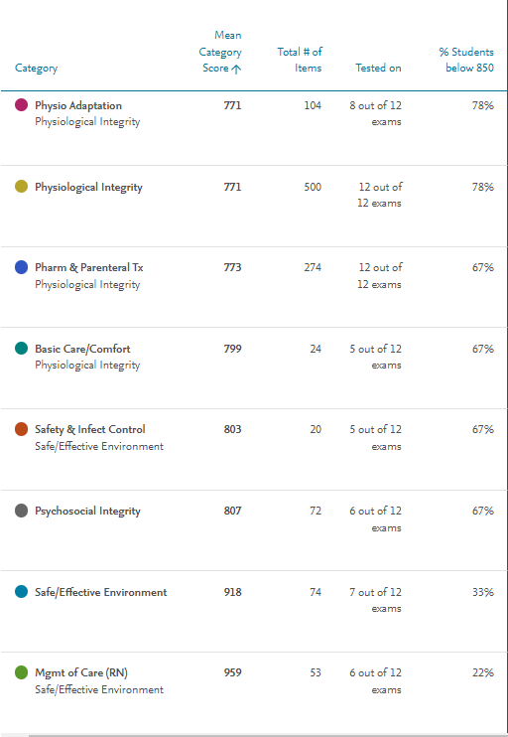

2. Use the research process through translation of evidence-based findings to advance professional nursing and the delivery of health care
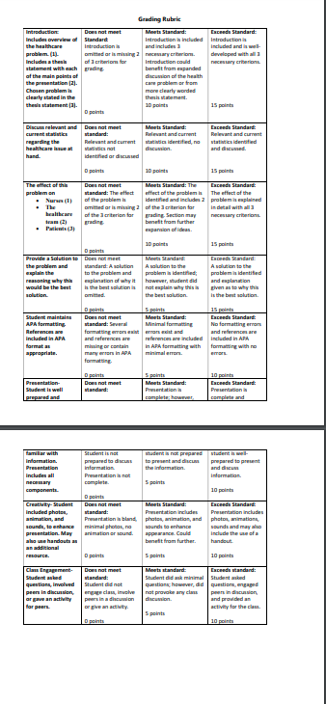
3. Incorporate information management and patient care technology in the delivery of quality patient-centered care.
4. Accept personal accountability for lifelong learning, professional growth, and commitment to the advancement of the profession.
5. Combine theoretical knowledge from the sciences, humanities, and nursing as a foundation to professional nursing practice that focuses on health promotion and prevention of disease for individuals, families, communities, and populations.
6. Employ inter-professional communication and collaboration to ensure safe, quality care across the lifespan.
7. Integrate ethical, legal, and professional standards into the practice of nursing.

