

**Academic Affairs Assessment of Student Learning**

**Report for Academic Year 2022-2023**

**Department/Program: Music**

**Assessment Coordinator’s Name: Scott E. Woodard**

**Assessment Coordinator’s Email Address: scott.woodard@wvstateu.edu**

1. **Which learning outcomes did you measure this past year?** [Please indicate whether any of these measures were conducted as follow-up to a previous year’s issues or in response to Program Review. Be specific.]

We measured all Program Learning Outcomes (PLOs) (1–6) for the Academic year of 2022-2023. PLOs 1, 2, 4, and 5 were assessed using formal, department-wide assessments. PLOs 3 and 6, while incorporated into courses assessed with formal assessment tools, were mostly assessed through class specific assessments in MUS 303 and 304 rather than department-wide assessments. The Music Department has undergone staff turnover that has significantly impacted its assessment plan and data collection since the implementation of the BFA. At the conclusion of Spring 2022, both the assessment coordinator and department chair left the University without passing along any plan or data. 2022-2023 marks a new starting point for assessment.

1. **In which course(s) were assessments conducted?**

Formal, department-wide assessments were administered in the following courses.

MUS 202 = PLOs 1 and 2

MUS 216 = PLO 5 (PLOs 1–3 are within the course objectives)

MUS 191–492 = PLOs 4 and 5 (PLOs 1–6 are within the course objectives.)

Informal, course specific assessments were administered in the following courses, which most directly address PLOs 3 and 6. A department-wide formal assessment is needed for these PLOs.

MUS 303, MUS 304 = PLOs 3 and 6

1. **How did you assess the selected program learning outcomes?** (i.e., what did you assess –group project, skills demonstration, presentation, performance, debate, lab experiment, online discussion, etc. *and*- what tool (measure) did you use - rubric, nationally or state-normed exam, item analysis, pre-posttest design, skills inventory, survey, etc.)

A description of the assessment tools, and what they assess, is below.

1. **Comprehensive Music Theory Examination (CMTE)** [See Exhibit I]. The CMTE is an assessment tool developed by our music theory professor and includes ***skills inventory and item analysis***. He employs a ***pre-posttest design***, with the pretest given before MUS 191 and posttest given after MUS 292. It is administered at the end of a student’s sophomore year to comprehensively assess ***PLOs 1 and 2***. This is a culmination of 4 semesters of music theory study (i.e. MUS 115, 116, 215, and 216).

2. **Piano Proficiency Exam (PPE)** [See Exhibit II]. The PPE was developed by our piano professor and is a ***skills inventory***. Students are required to pass the PPE prior to graduation. This exam is a summation of 4 semesters of piano study (MUS 110, 111, 210, and 211) and is typically taken following a student’s sophomore year. It directly measures ***PLO 5***, but piano playing provides a foundation to analyze music literature ***(PLOs 1 and 2)*** and, in turn, to differentiate between the various periods of music history ***(PLO 3)***. THE FORMAT OF THE PIANO PROFICIENCY IS CURRENTLY UNDER REVIEW WITH THE NEW ADJUNCT PIANO INSTRUCTOR AND WILL BE REVISED DURING THE 2023-2024 ACADEMIC YEAR.

3. **Scale Jury Form (SJF)** [See Exhibit III)]. The SJF was developed by our instrumental faculty and is a ***skills inventory***. Instrumental students are required to pass a scale jury during their first 4 semesters of applied music study. The SJF directly assesses ***PLO 5***. Each scale must be mastered prior to graduation, though most students complete their scale jury requirement following their sophomore year of study.



4. **Jury Evaluation Form (JEF)** [See Exhibit IV]. The JEF was developed by our music faculty and is a ***skills inventory through narrative feedback***. It includes a Likert Scale for grade assignment. Students are required to present a juried performance for the music faculty at the end of each semester during their first seven semesters of lessons. This is a direct assessment of ***PLOs 4 and 5***.

5. **Applied Music Performance Rubric (AMPR)** [See Exhibit V]. The AMPR was developed by the music faculty and is a ***skills inventory in rubric format***. Students demonstrate their graduate performance abilities through a juried senior recital typically presented during their eighth semester of applied study. This is a direct assessment of ***PLOs 4 and 5***. This final recital is preceded by a juried hearing conducted by a committee of music faculty at least 4 weeks prior to determine adequate preparation. Faculty use the “Applied Music Performance Rubric” to assess the hearing.

1. **How many students were included in the assessment(s) of each PLO in a course?**

**MUS 191–492 (JEF, SJF): Fall 2022 – 19**

**MUS 191–492 (JEF, SJF): Spring 2023 – 25**

**MUS 202 (CMTE): Spring 2022 – 5**

**MUS 216 (PPE): Spring 2019 – PIANO PROFICIENCY UNDER REVIEW**

1. **How were students selected to participate in the assessment of each outcome (**Helpful details might include- whether this assessment represents all students, a sample of students in a class, or a sample of students across sections)?

Each assessment is administered to every student in the applicable course.

1. **In general, describe how each assessment tool (measure) was constructed** (i.e. in-house, national, adapted).

Each of our 5 assessment tools for the BFA were constructed in-house using informal comparison/research of peer-institution assessment measures.

1. **Who analyzed results and how were they analyzed**

The new department chair, appointed in September of 2022, is also serving as the assessment coordinator due to the high number of term faculty (2 of 3) in the Music Department who are exempt from University service. He has maintained records of scale jury scores and jury scores during the 2022-2023 academic year. The music theory professor has administered the CMTE for the past 3 years and has reported this data to the music department chair.

Analysis of each year’s CMTE, SJF, JEF, and AMPR data will be analyzed each summer beginning in Summer 2023 and will be compared to scores over the previous 4 years, where data is available, looking for observable trends in student performance and using this data to improve instruction. The PPE is pass/fail, so no analysis of scores is needed. However, a record of failed attempts will be kept to help the piano instructor adapt instruction to those areas of student struggle.

1. **Provide a summary of the results/conclusions from the assessment of each measured Program Learning Outcome.** *Report scores for this assessment, as well as students’ strengths and weaknesses relative to this learning outcome.*
2. **What are next steps?** (e.g., will you measure this same learning outcome again? Will you change some feature of the classroom experience and measure its impact? Will you try a new tool? Are you satisfied?)

The Music Department will continue to measure the same learning outcomes in 2023-2024. We will consider an improvement to the Jury Evaluation Form that allows for more specific evaluation of individual musical elements rather than a strictly narrative approach. We will also consider a formal, department-wide assessment of music history to implement in 2024–2025 when the music history courses will be taught again in order to better assess PLOs 3 and 6. Instructors receive copies of their students’ JEF’s each semester, and use these as feedback for their classroom teaching. The department chair will encourage the music theory professor and piano professor to reflect on their own classroom instruction based on the results of the CMTE and PPE.

1. **Please attach an example of the assessment tool used to measure your PLO(s).** These can be added as an appendix, a link to the assessment, or sent separately in email with your report.

**FORMAL ASSESSMENTS**

**N.B.: THE CURRENT ITERATION OF THE CMTE AND THE PIANO PROFICIENCY IS DATED AND UNDER REVIEW FOR EDITING BY THE FACULTY DURING THE 2023-2024 ACADEMIC YEAR.**

**Exhibit I: Comprehensive Music Theory Examination (Excerpts)**

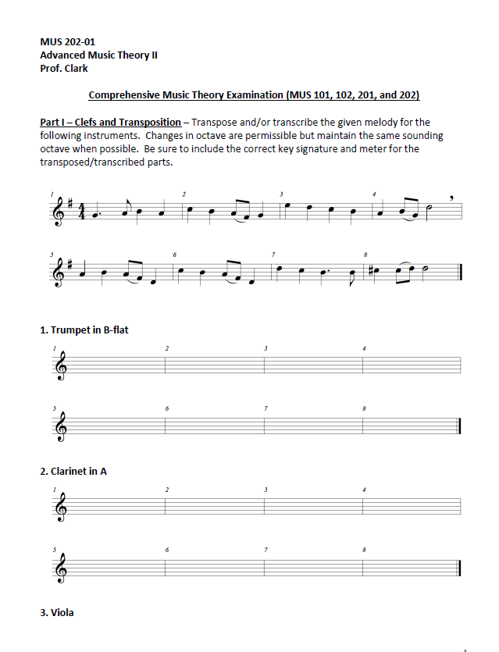

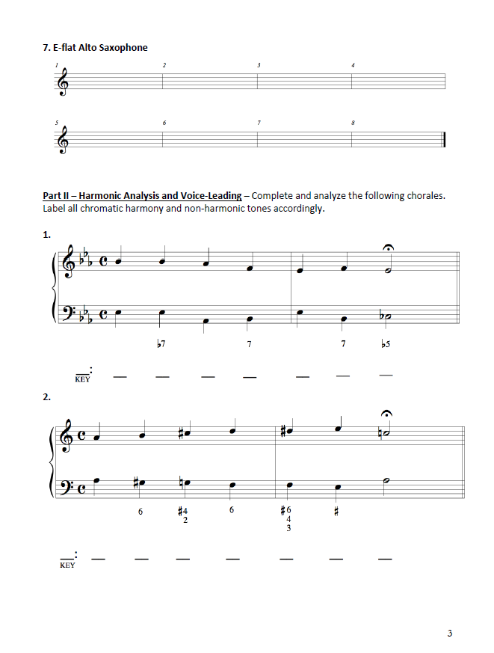

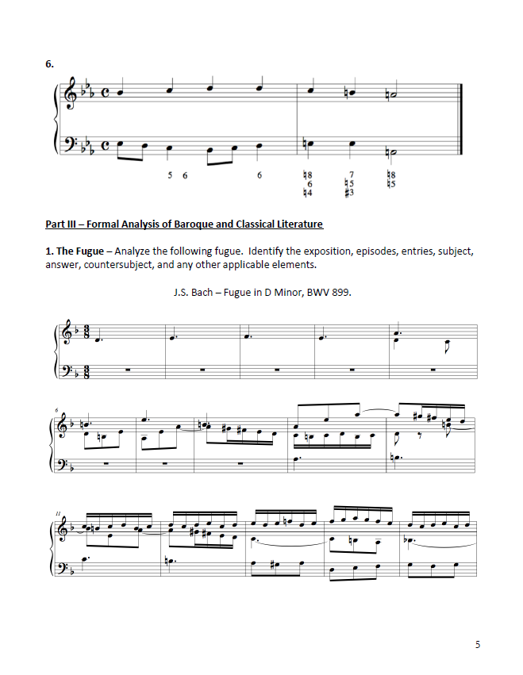

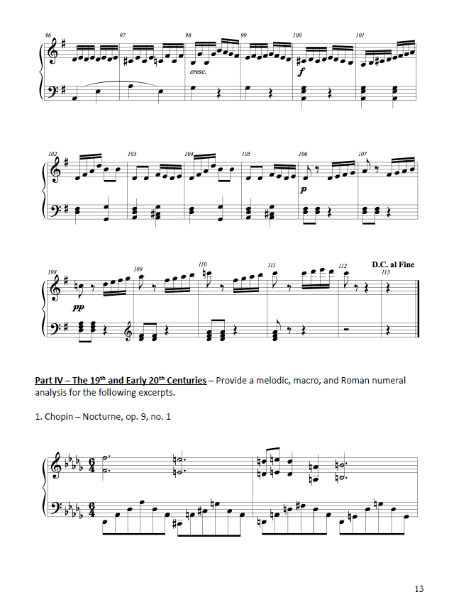

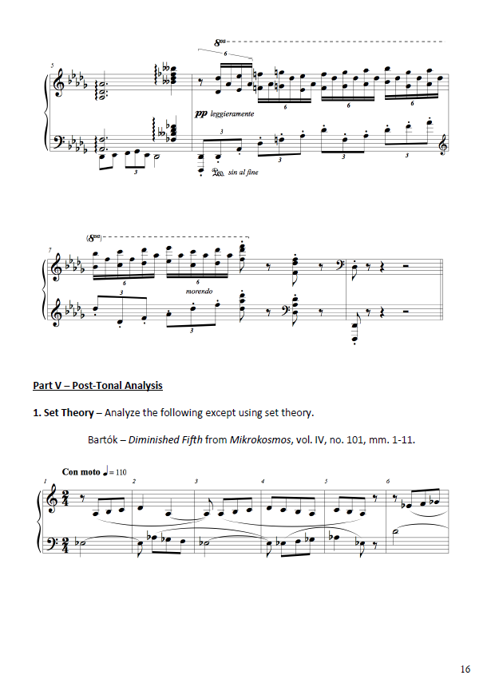

**Exhibit II: WVSU Piano Proficiency Requirements**

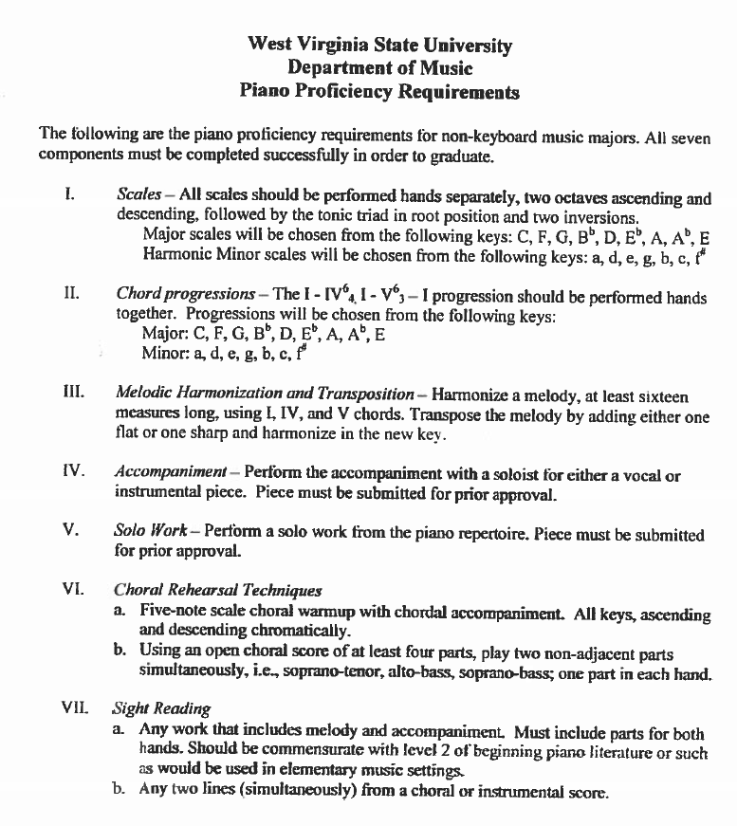

**Exhibit III: WVSU Scale Jury Form**

Scale Juries

WVSU Department of Music

**NAME: Semester:**

|  |  |  |  |  |  |  |  |  |
| --- | --- | --- | --- | --- | --- | --- | --- | --- |
| **Level:** | 191 | 192 | 291 | 292 | 391 | 392 | 491 | 492 |

|  |  |  |  |  |  |  |  |
| --- | --- | --- | --- | --- | --- | --- | --- |
| Scale | M | Nm | Hm | Mm | P | F | Notes |
| C |  |  |  |  |  |  |  |
| G |  |  |  |  |  |  |  |
| D |  |  |  |  |  |  |  |
| A |  |  |  |  |  |  |  |
| E |  |  |  |  |  |  |  |
| B/Cb |  |  |  |  |  |  |  |
| F#/Gb |  |  |  |  |  |  |  |
| C#/Db |  |  |  |  |  |  |  |
| Ab |  |  |  |  |  |  |  |
| Eb |  |  |  |  |  |  |  |
| Bb |  |  |  |  |  |  |  |
| F |  |  |  |  |  |  |  |

**Composite Grade:**

Please initial and circle:

|  |  |  |  |  |  |
| --- | --- | --- | --- | --- | --- |
| ______ | ______ | ______ | ______ | ______ | ______ |
| Clark | Norman | Johnson | Vanderford | Woodard | Other |

**Exhibit IV: WVSU Jury Evaluation Form**

West Virginia State University Department of Music

**JURY EVALUATION FORM**

__________Semester, 20________

STUDENT: __________________________________________________________________

INSTRUMENT/VOICE: _______________________________________________________

COURSE: 191 191A 192 291 292 391 392 491 492

LEVEL (1.0-10.0):_________

1. RATING on a scale from 1- 12 *(circle appropriate numbers):*

---F--- ---D--- ---C--- ---B--- ---A---

0 1 2 3 4 5 6 7 8 9 10 11 12

1. Brief Comments on Performance *(Write additional comments on the back of this form.):*
2. Literature
3. Technique
4. Musicality
5. Other

FACULTY: *Circle and Initial*

*________ ________ ___________ ________ _________ ____________________*

*Clark Johnson Vanderford Norman Woodard Other (write name above)*

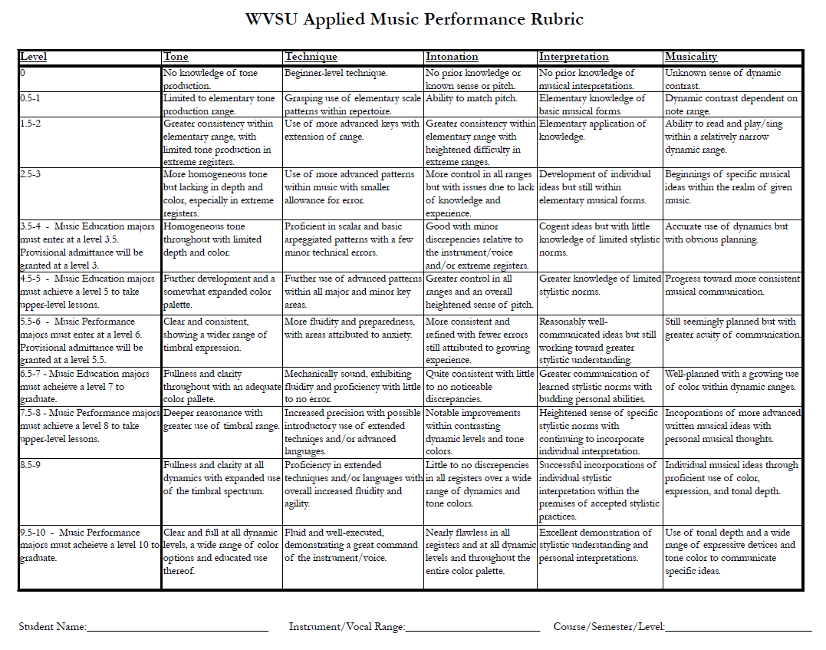**Exhibit V: WVSU Applied Music Performance Rubric**