

**Academic Affairs Assessment of Student Learning**

**Report for Academic Year _**__2021_-__2022__

**Department/Program __Communication and Media Studies**

**Assessment Coordinator’s Name: Dr. Ali Ziyati**

**Assessment Coordinator’s Email Address: aziyati@wvstateu.edu**

1. **Which learning outcomes did you measure this past year?** [Please indicate whether any of these measures were conducted as follow-up to a previous year’s issues or in response to Program Review. Be specific.]

*The Program assessed 1 and 3 learning outcomes for the Academic year of 2020-2021. These are:*

*1. Evaluate communication research.*

*3. Create content appropriate to communication context.*

*PLO 2 (Interpret theoretical communication concepts),*

*PLO 4 (Apply ethical considerations appropriate to communication contexts), and*

*PLO 5 (Interpret laws relevant to communication) are to be assessed at a later semester.*

1. **In which course(s) were assessments conducted?**

*COMM 162 = PLO 3*

*COMM 205 = PLO 1*

*COMM 360 = PLO 3*

*COMM 400 = PLO 3*

1. **How did you assess the selected program learning outcomes**

* *PLO 1 was assessed using COMM 205 (Intro to Public Relations) students’ efforts to research internal and external factors of their selected non-profit organizations. The course used a rubric to assess students’ research methods, findings and how they used the results to plan and implement communication strategies and tactics for their non-profit organizations.*
* *PLO 3 was assessed in three different courses.* 
  + *In COMM 162 (Intro to TV Production), a rubric was used in both semesters to assess the assignment of writing, shooting and editing a 2 to 3-minute news package.*
  + *In COMM 360 (Advanced TV Production and Direction), a rubric was used in both semesters to assess the assignment of writing, shooting and editing a 2 to 3-minute news package as part of a 15-minute public affairs program aired by West Virginia Public Broadcasting (WVPB).*
  + *In COMM 400 (Capstone/Internship), a rubric was used to assess students’ production skills and outcomes as they present their overall experiences to the faculty by the end of the semester.*

1. **How many students were included in the assessment(s) of each PLO in a course?**

*COMM 162 (2020-21) = 14*

*COMM 205 (2020-21) = 21*

*COMM 360 (2020-21) = 9*

*COMM 400 (2020-21) = 8*

1. **How were students selected to participate in the assessment of each outcome (**Helpful details might include- whether this assessment represents all students, a sample of students in a class, or a sample of students across sections)?

*All of the students in each class that programmatic learning outcomes were assessed. The capstone is an exception since only 10 out of 21 students were able to complete their internship in time.*

1. **In general, describe how each assessment tool (measure) was constructed** (i.e. in-house, national, adapted).

*All rubrics are constructed in-house. Each instructor develops rubrics specific to their courses using the departmental distribution of PLOs assigned to each course. The capstone’s rubric however, is an exception since the department issued and adopted the rubric earlier.*

1. **Who analyzed results and how were they analyzed**

*Basic averaging was utilized by individual instructor. The assessment liaison compiled, organized and reported all the data.*

1. **Provide a summary of the results/conclusions from the assessment of each measured Program Learning Outcome**

**ASSESSMENT DATA**

1. **Assessment Data collected from COMM 400 Capstone/Internship Experience. (Data is the average scores given in the FINAL column for the PLO # 3 only. Other PLOS will be assessed individually in each semester).**

|  |  |  |  |  |  |
| --- | --- | --- | --- | --- | --- |
| PLO/Academic Semester | PLO 1 | PLO 2 | PLO 3 | PLO 4 | PLO 5 |
| Fall 2021 (2) |  |  | 4.00 |  |  |
| Spring 2022 (8) |  |  | 3.8 |  |  |

**Discussion:**

The COMM 400 is usually a very hectic course/experience. We use the internship to cover all PLOS. We only used this time to PLO 3 since after all, it’s the students’ production skills that would land them jobs. Reviewing students portfolios, contacting their field supervisors and getting their written and oral feedbacks, along with students final presentations allowed us to assess, not only the course, but to also have an overall look at the program in its totality.

1. **Assessment collected from COMM 205 (Intro to Public Relations).** PLO 1 was assessed using COMM 205 (Intro to Public Relations) students’ efforts to research internal and external factors of their selected non-profit organizations. The course used a rubric to assess students’ research methods, findings and how they used the results to plan and implement communication strategies and tactics for their non-profit organizations.

|  |  |  |  |  |  |
| --- | --- | --- | --- | --- | --- |
| **Exam Section/**  **Academic year** | **Mastery** | **Accomplished** | **Developing 1** | **Beginner** | **Unacceptable** |
| Spring 2022 (18) | 8 (44.4) | 4 (22.2) | 6 (33.3) | -- | -- |
| Fall 2021 (9) | 3 (33.3) | 3 (33.3) | 1 (11.1) | 2 (22.2) | -- |

**Discussion:**

Having taken COMM 101 (Intro to mass Communication) made it a bit easier to emphasize the importance of research and research methods. Students are not usually familiar with different types and methods while doing research. Guiding students throughout the process made a difference. Not all students did actually grasp the significance and practice of collecting data and information through interviews, for example.

1. **Assessment Data collected from COMM 162 (Intro to TV Production)** used both semesters to assess the assignment of writing, shooting and editing a 2 to 3-minute news package. The Fall 2020 had an enrollment of 8 students only. Spring 2022 had an enrollment of 6 students. The data collected and displayed below are the average scores per academic semester. The assignment assesses Video skills and production as part of PLO 3.

**Video**

|  |  |  |  |  |  |
| --- | --- | --- | --- | --- | --- |
| **Exam Section/**  **Academic year** | **Mastery** | **Accomplished** | **Developing 1** | **Beginner** | **Unacceptable** |
| Spring 2022 (6) | 33.3% | 50% | 16.7% | -- | -- |
| Fall 2021 (8) | -- | 37.5 | 25 | 12.5 | 12.5 |

**Audio**

|  |  |  |  |  |  |
| --- | --- | --- | --- | --- | --- |
| **Exam Section/**  **Academic year** | **Mastery** | **Accomplished** | **Developing 1** | **Beginner** | **Unacceptable** |
| Spring 2022 (6) | 16.6 | 66.6 | 16.6 | -- | -- |
| Fall 2021 (8) | -- | 62.5 | 25 | 12.5 | -- |

**Writing:**

|  |  |  |  |  |  |
| --- | --- | --- | --- | --- | --- |
| **Exam Section/**  **Academic year** | **Mastery** | **Accomplished** | **Developing 1** | **Beginner** | **Unacceptable** |
| Spring 2022 (6) | -- | 83.3 | 12.5 | -- | -- |
| Fall 2021 (8) | -- | 37.5 | 37.5 | 12.5 | -- |

Appeal:

|  |  |  |  |  |  |
| --- | --- | --- | --- | --- | --- |
| **Exam Section/**  **Academic year** | **Mastery** | **Accomplished** | **Developing 1** | **Beginner** | **Unacceptable** |
| Spring 2022 (6) | 50 | 50 | -- | -- | -- |
| Fall 2021 (8) | 12.5 | 50 | 25 | 12.5 | -- |

**Discussion:**

The Fall 2021 class was an unusually small. I believe that made the assessment process more difficult as there were fewer projects to grade and all of the students produced very passable projects considering the stress caused by the Covid19 pandemic.

Students were able to identify stories that were interesting and were competent with the production and post production processes but seem to be lacking in the ability to write for television media. They did not introduce or transition through the use of paraphrasing what the interviewees had said.

The Spring 2022 was even smaller than the fall class. It was again an unusual sample. The pandemic had subsided and students felt more comfortable with assignments. The slightly elevated scores can be contributed to that and the individual time and attention available to the small group throughout the semester.

1. **Assessment Data collected from COMM 360 (Advanced TV Production)** used both semesters to assess the assignment of writing, shooting and editing a 2 to 3-minute news package. The Fall 2021 had an enrollment of 6 students only. Spring 2022 had an enrollment of 3 students. The data collected and displayed below are the average scores per academic semester. The assignment assesses Video skills and production as part of PLO 3.

**Video**

|  |  |  |  |  |  |
| --- | --- | --- | --- | --- | --- |
| **Exam Section/**  **Academic year** | **Mastery** | **Accomplished** | **Developing 1** | **Beginner** | **Unacceptable** |
| Spring 2022 (3) | 66.6 | 33.3 | -- | -- | -- |
| Fall 2021 (6) | 50 | 50 | -- | -- | -- |

Audio

|  |  |  |  |  |  |
| --- | --- | --- | --- | --- | --- |
| **Exam Section/**  **Academic year** | **Mastery** | **Accomplished** | **Developing 1** | **Beginner** | **Unacceptable** |
| Spring 2022 (3) | 33.3 | 66.6 | -- | -- | -- |
| Fall 2021 (6) | 50 | 33.3 | 16.6 | -- | -- |

Writing:

|  |  |  |  |  |  |
| --- | --- | --- | --- | --- | --- |
| **Exam Section/**  **Academic year** | **Mastery** | **Accomplished** | **Developing 1** | **Beginner** | **Unacceptable** |
| Spring 2022 (3) | -- | 100 | -- | -- | -- |
| Fall 2021 (6) | 33.3 | 33.3 | 33.3 | -- | -- |

Appeal:

|  |  |  |  |  |  |
| --- | --- | --- | --- | --- | --- |
| **Exam Section/**  **Academic year** | **Mastery** | **Accomplished** | **Developing 1** | **Beginner** | **Unacceptable** |
| Spring 2022 (3) | 66.6 | 33.3 | -- | -- | -- |
| Fall 2021 (6) | 83.3 | 16.6 | -- | -- | -- |

**Discussion:**

The fall 2021 semester was actually a very difficult semester to assess student work progression. Students faced an extremely difficult time getting people to consent to be interviewed during this semester. Most of the assignments were focused on personal friends and family members since they were more likely to be available to the student. All but one story was about dealing with the difficulties of navigating work, school or finances during the preceding months.

During Spring 2022, this class was even smaller than the fall class. It was again an unusual sample. The pandemic had subsided and students felt more comfortable with assignments. However, all three assignments involved the use of Zoom recorded interviews. This was a new element and our students had little experience recording and editing. Overall I believe they did very well.

1. **What are next steps?** (e.g., will you measure this same learning outcome again? Will you change some feature of the classroom experience and measure its impact? Will you try a new tool? Are you satisfied?)

Similar assessment processes will be in place each semester. The same will be evaluated in Fall 2023. Others are being assessed in the time being. We will continue to use the capstone/internship as the grand course to assess the program successes and areas to improve.

1. **Please attach an example of the assessment tool used to measure your PLO(s).** These can be added as an appendix, a link to the assessment, or sent separately in email with your report.

**Exhibit 1: COMM162 Rubric**

**Exhibit 2: COMM 360 Rubric**

**Exhibit 3: COMM 101 Rubric**

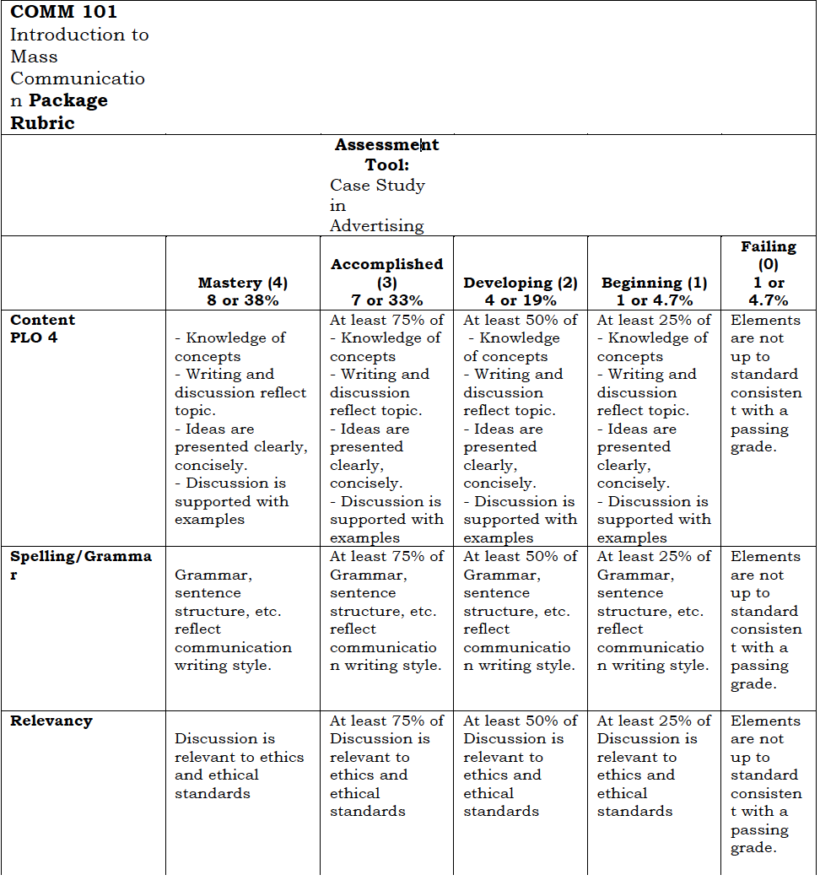

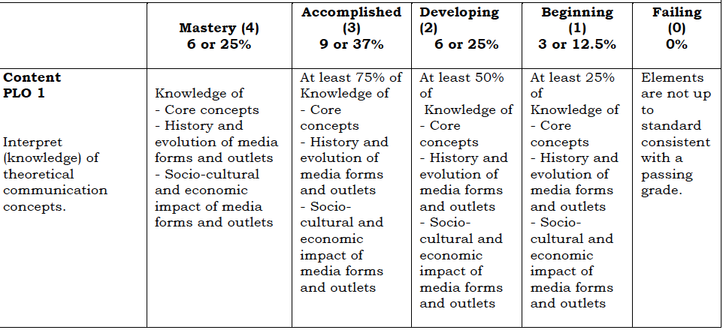

**Exhibit 4: COMM 205 Rubric**



**Exhibit 5: COMM 205 Rubric** 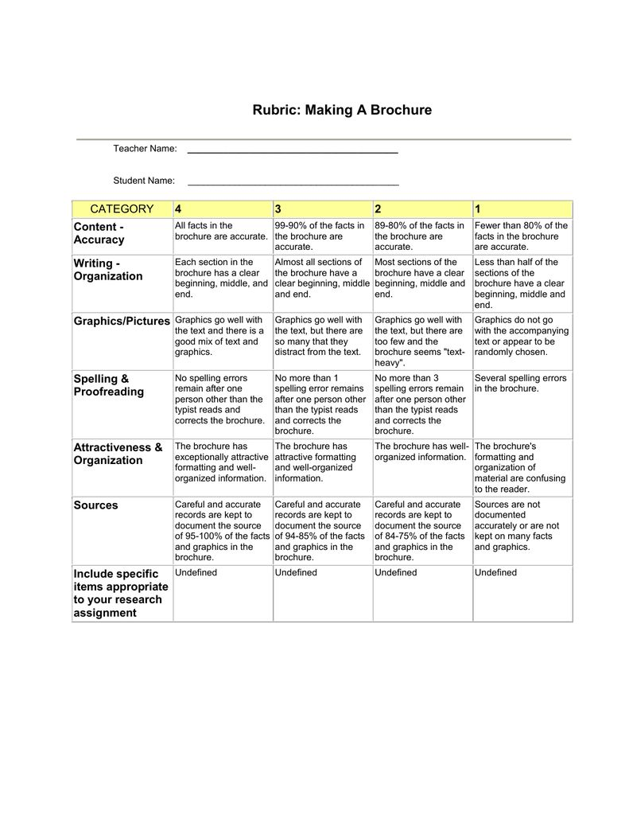

**Exhibit 6: COMM 400 Rubric**

