Measure 2: Indicators of Teacher Effectiveness
Initial Level

A misunderstanding related to the definition lead the EPP to previously report data associated with candidates and not actual completers. The EPP immediately began efforts to rectify this oversight during the Fall 2019. Yet the planning phase, combined with the pandemic of Spring 2020, impeded these efforts. The EPP created a plan and piloted methods to collect and analyze data that demonstrates that our completers meet the four components of Standard 4 as outlined in the CAEP handbook for EPP-Created Assessments, which included creating a completer survey (CS), revising the employer survey (ES), using the graduate database to identify and contact completers through emails and by phone, and arranging meetings with administrators in Professional Development Schools (PDS) to discuss collecting evidence.
Due to a lack of data provided by the WVDE, we have opted to use the information from our piloted initiative to capture data applicated to Annual Reporting Measure 2: Indicators of Teacher Effectiveness. The following charts reflect responses from both completers and their employers. We have chosen to highlight select items from the respective surveys yet a full reporting of these findings has been placed upon the WVSU Education Department website.
The following charts are items associated with teaching effectiveness, as reported by completers:

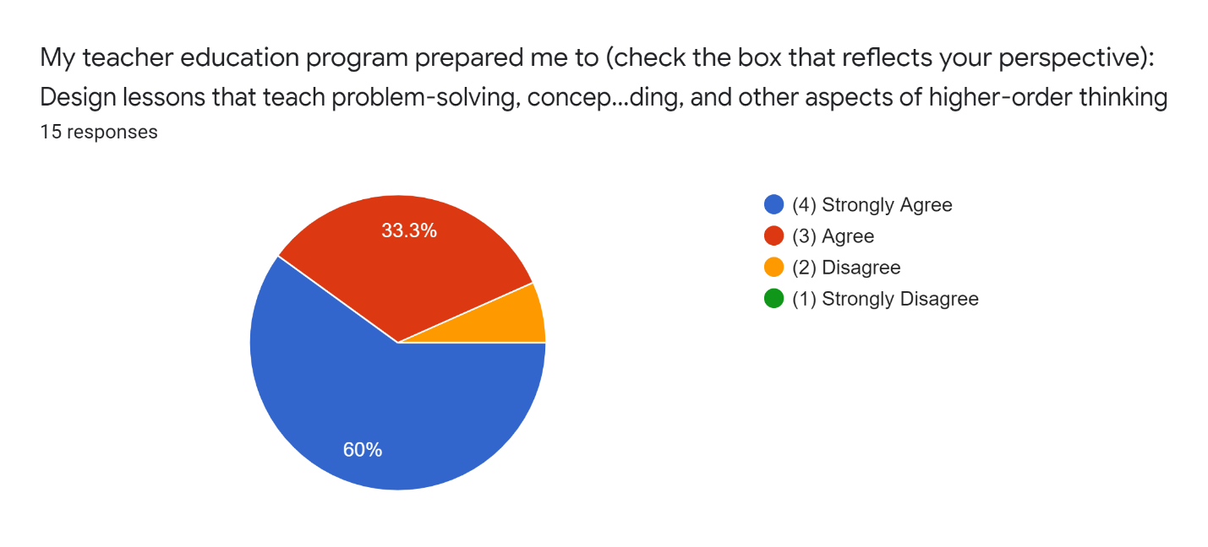

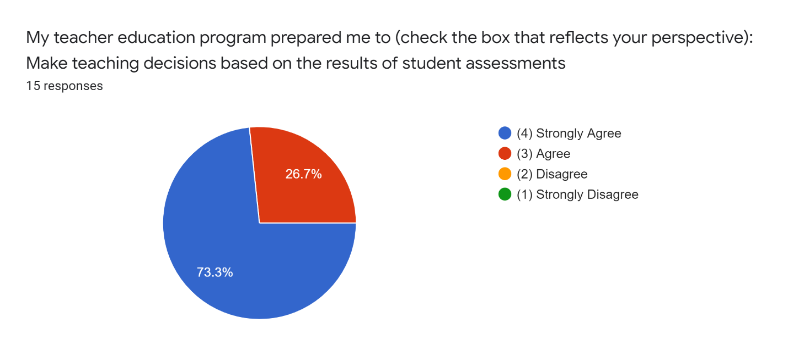

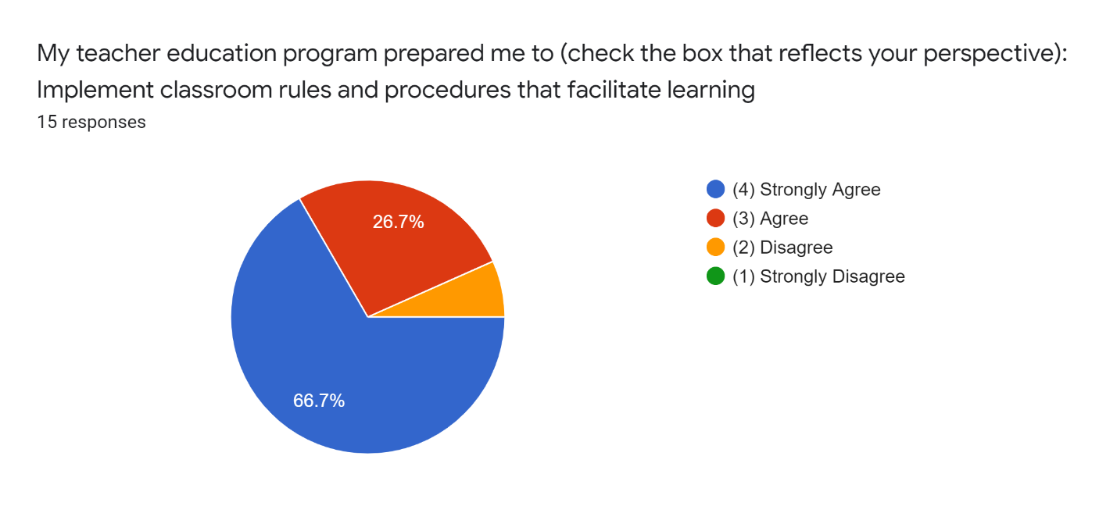

Completers indicate a high level of agreement regarding their preparation as it relates to the criteria for these select items: problem solving/higher order thinking within lessons, use of assessment and classroom management. Conversely, we will consider the responses of employers on these same criteria in the charts below.
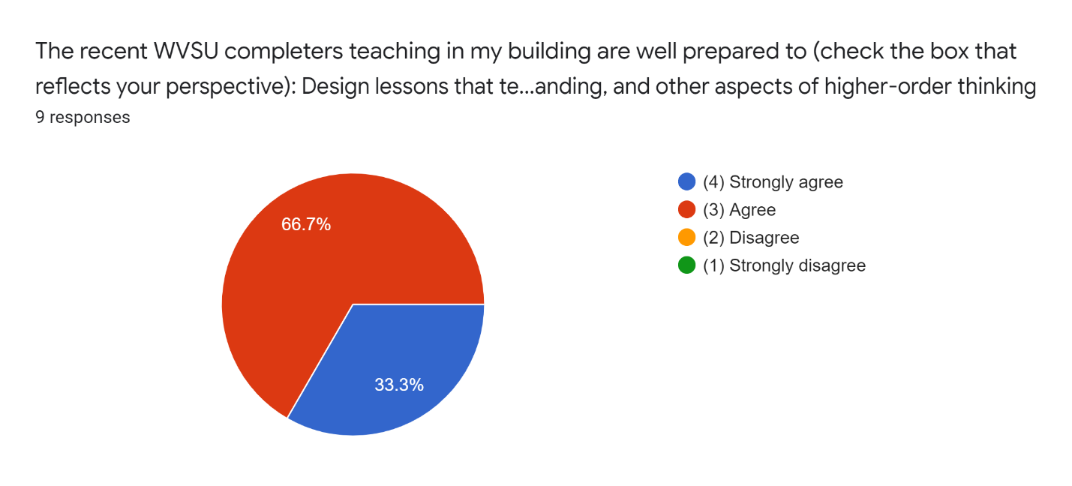

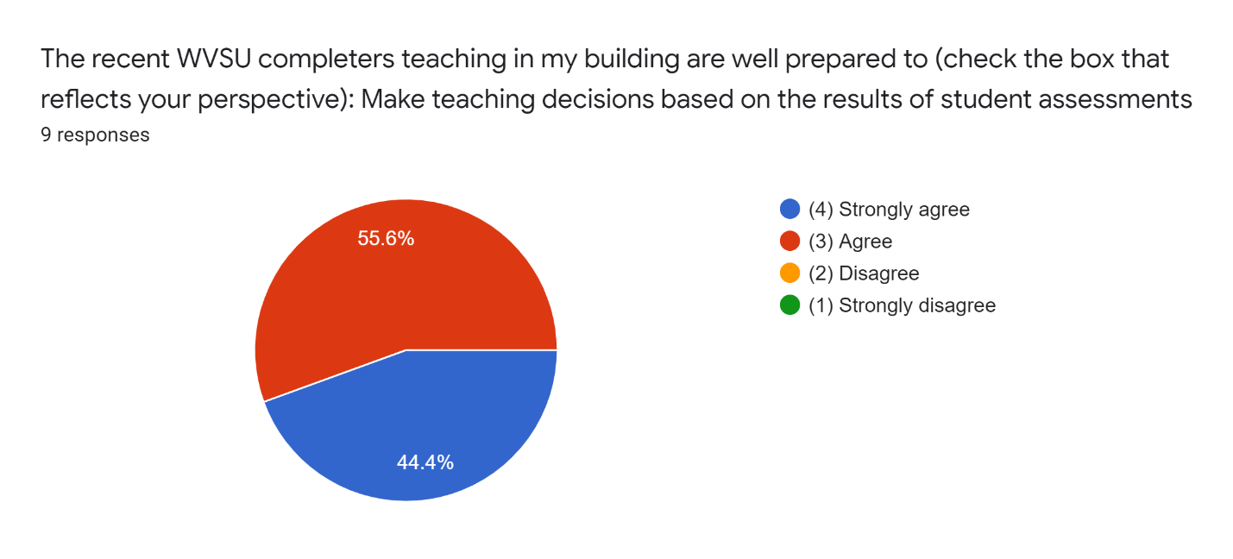
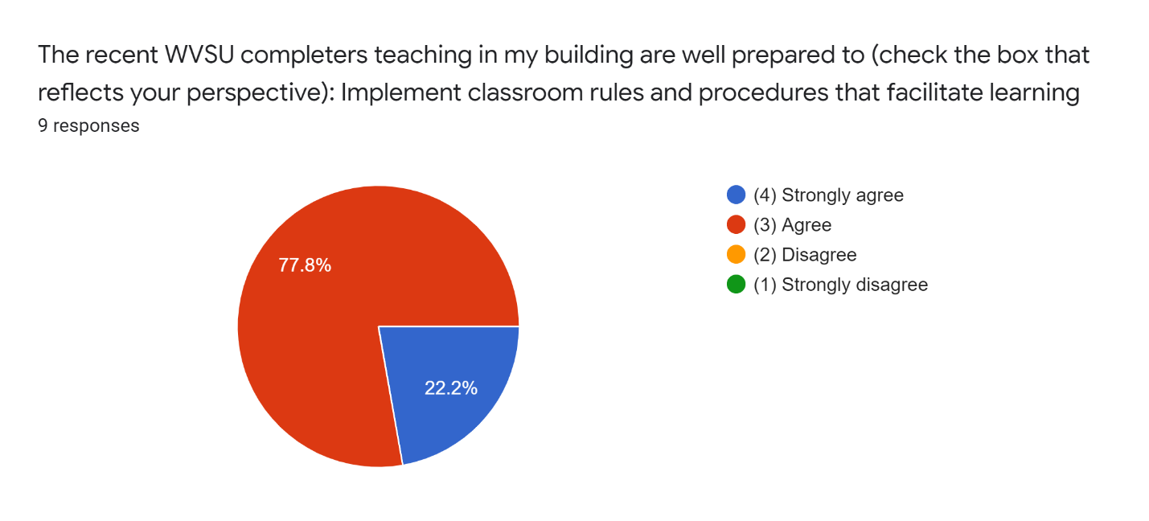
The results indicate that employers are also in strong agreement/agreement regarding completer ability to address the select criteria within each of the charts. Consideration will be given to the items noted that fall below the ‘agree’ response category during full faculty meetings in which this data will be shared and used to shape programmatic change.

