Measure 1: Impact on P-12 Learning and Development
Initial Level
Prior to Fall 2020, the EPP collected Exit Survey data from student teachers as they exited the program due to a misunderstanding of the term “completer.” The EPP did not receive feedback on our annual CAEP report until the Fall of 2019. It was at that time that we were informed that our definition of completer, previously defined as exiting student teachers, did not align with CAEP’s definition of completers. At that time, the EPP began formulating a plan for how to proceed with data collection. This was further hindered in the Spring 2020 semester due to school closures due to the COVID-19 pandemic.

Given the time needed to generate a plan during Fall 2019 and then the resulting shut down during Spring 2020, efforts to collect completer data have been highly complicated. Moving forward we have a plan outlined for the collection of such data by means of an alumni advisory board with particular focus being given on the acquisition of public-school student testing data which would serve to address the requirements of Measure 1. At present, the state of WV does not provide such data to higher education entities. For present reporting purposes, we have chosen to use data from our piloted Alumni Advisory Board, as well as the Transition to Teaching Survey data provided by the WVHEPC.
The Transition to Teaching Survey (TTS) collects information on recent graduates’ licensure and job status, perceptions of their teacher preparation programs, current school contexts, and personal demographics. Unfortunately, the 2019 TTS response rate was 22% (11 out of 49 with a few individuals failing to complete the entire instrument) which provides a limited capture of the elements being examined. We received responses from 15 completers to our invitation to participate in the Alumni Advisory group.
Responses from the Alumni Advisory group will be featured first.

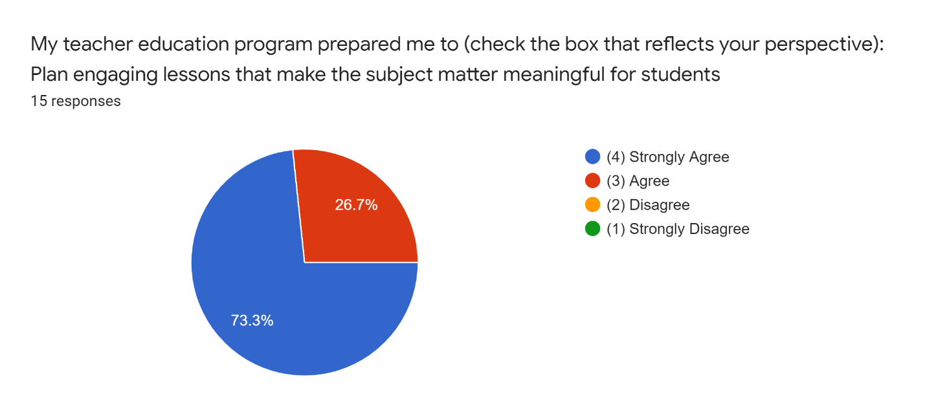
Alumni indicate strong agreement in their preparation to create/implement engaging lessons which strongly impacts student learning and development. The charts below denote completer responses to several items which serve to impact student learning:

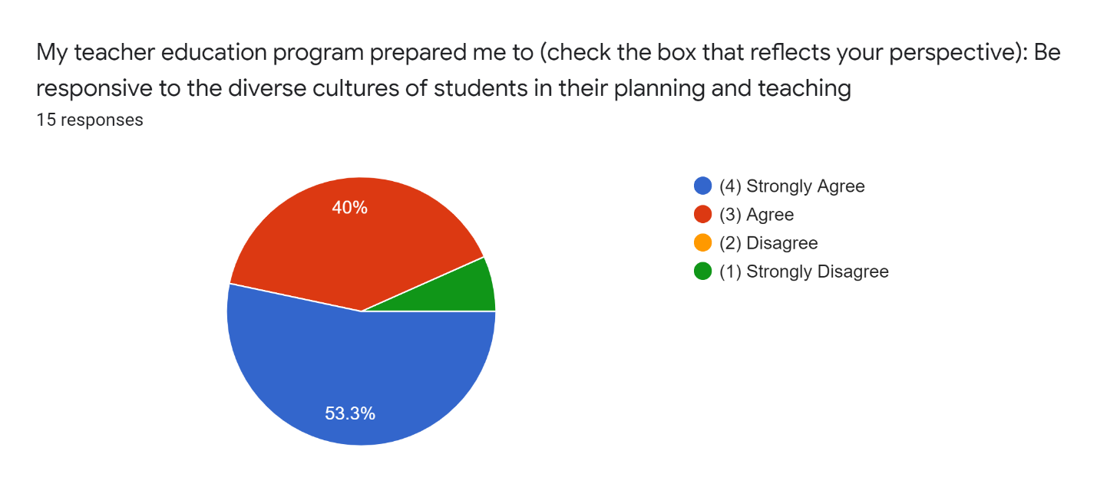

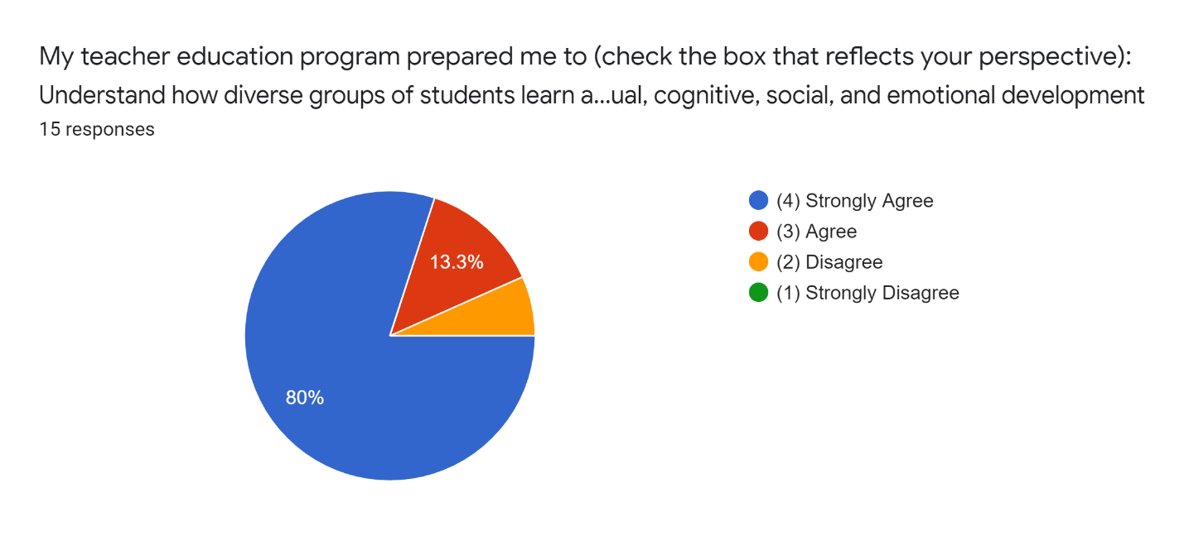
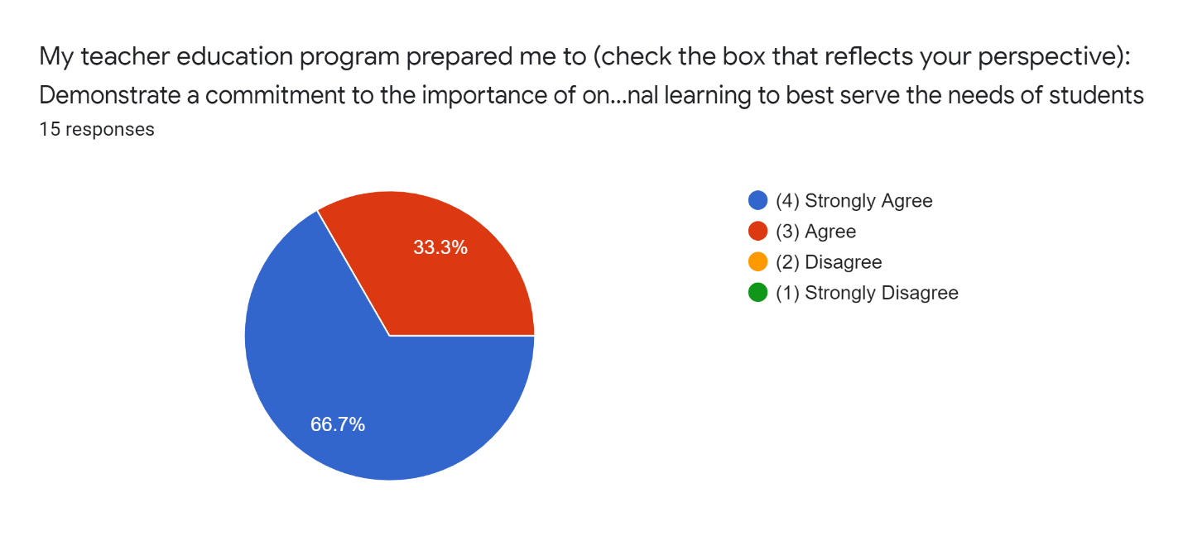

The following TTA charts denote completer responses regarding their preparation to create an effective learning environment within their classrooms. The EPP considers this to be a fundamental element necessary to ensure a positive impact on student learning.
The TTS 2019 Survey results indicate that WVSU completers have a high-level satisfaction with their preparation to create positive learning environments. Table 37 below is related to completer perceptions of their professional work environment. Responses related to ‘continual learning and seeking of new ideas to enhance practice’ and ‘influence over establishing curriculum’ are underlying factors that support student growth and development. The responses for each indicated that WVSU completers agree or tend to agree that these opportunities are made available to them as educator.

