CAEP Annual Report 2022
Measure 1: Impact on P-12 Learning and Development
Initial Level
For present reporting purposes, we have chosen to use data from our piloted Alumni Advisory Council survey and AAC Action Research initiative.
No Transition to Teaching Survey data was provided by the WVHEPC/WVDE due to poor return rates for the TTS and accompanying employer survey. (It should be noted that Fall 2021 will be the last any statewide collection of data with the NeXT Survey of Fall 2021 being the final statewide collection attempt). As a result, the EPP opted to collect completer/employer data using the Skyfactor platform. This shift in platforms was made in hopes of attaining higher response rates from the target populations.

Contributions to P-12 Student Learning Growth
At present, the state of WV does not provide such disaggregated P-12 student data to higher education entities which would aid in measuring our completer impact upon student learning. Therefore, we are solely reliant upon the participation of completers for such data. To further support data collection efforts with our completers, WVSU has attempted to collect data by way of an Alumni Advisory Council (ACC). However, participation has been very limited.
Responses from the EPP created Alumni Survey will be featured first, followed by P12 student data provided by the one AAC action research participant. It should be noted that the Fall 2021 Alumni Advisory responses to survey consisted of an n=2 with a single completer working with the EPP as a part of the AAC action research project to obtain completer data in Spring 2021-Fall 2021. Unfortunately, the EPP was unable to obtain any alumni participation in the AAC work for Spring 2022.
As previously stated, the AAC action research project consisted of a single completer who participated in the project during Spring 2021-Fall 2021. The individual graduated WVSU during Fall 2020 and was subsequently employed within their field of study as a secondary English Language Arts teacher. Their participation in the research consisted of many activities but for the focus of this reporting, we will use data related to the completers ability to impact student learning (as reported by pre/post data as well as student reported on the Panorama Survey).
Action Research Pre/Post Data
The completer selected a unit of study tied to improving student writing. He collected pre/post data associated with student knowledge of the writing process. After the collection of pre-instruction data, the completer worked closely with one of the EPP’s AAC faculty supervisors to discuss instructional strategies, planning and other elements of the instructional process to aimed at improving student writing skills. The chart below denotes the pre/post data sample for students in one of the completer’s classes:
Student Pre-Test and Post-Test Data on The Writing Process
Maximum Score: 10/10
Student Initials | Pre-Test Score | Post-Test Score
KB | 6 | 10
JB | 6 | 7
EB | 7 | 10
HB | 6 | 9
CC | 6 | 10
RC | 7 | 10
CC | 8 | 7
AC | 5 | 10
AF | 8 | 9
FH | 5 | 7
AH | 7 | 6
NM | 8 | 9
TM | 6 | 10
LM | 6 | 0 - Cheated on exam**
BO | 5 | 10
JP | 6 | 9
BR | 7 | 6
KR | 3 | 10
JS | 6 | 7
IT | 6 | 8
ET | 8 | 10
**Had another student’s device beside him with the answer key while testing.

The analysis of pre/post data reveals a significant improvement in student performance with only three P12 student failing to show improvement when post assessment data was collected.

Completer Impact on P-12 Learning—P-12 Student Feedback
Due to the lack of P-12 student data available to the EPP, as well as a lack of supervisor data for our completers, we opted to use the Panorama Survey with our AAC participants to obtain data related to impact on student learning. Panorama Student Survey is a set of survey scales, or groups of questions, that measure student perceptions of teaching and learning, as well as perceptions of school climate and their own strengths and weaknesses. Each scale has a substantial and growing body of evidence of its validity across specific contexts and uses. The EPP believes that students have an essential role to play in informing teaching effectiveness: this feedback instrument provides teachers and principals with valuable data about how students see their classes and how to facilitate improvement thus underscoring our decision to make use of the survey as a part of our data collection process.
The AAC action research participant administered the survey to the students enrolled in his classes with a participation rate of n=90 (with a few questions not being answered by all participants). The responses below are a representative sampling of survey items which we felt were most representative of the completer’s impact upon P-12 learning:
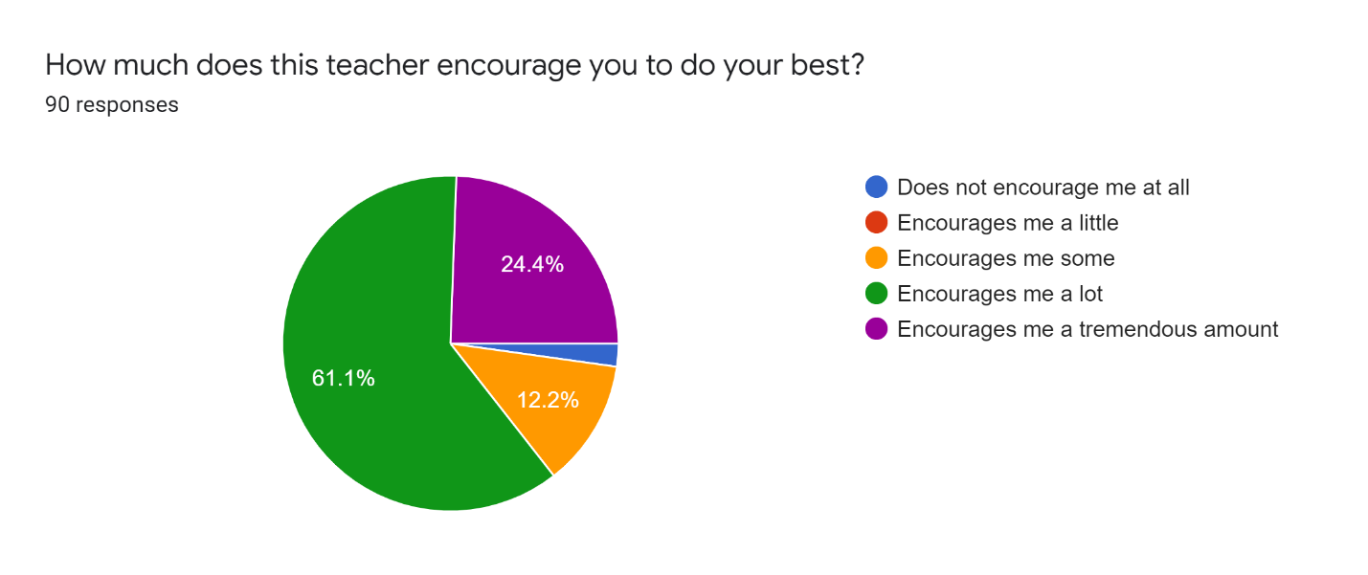

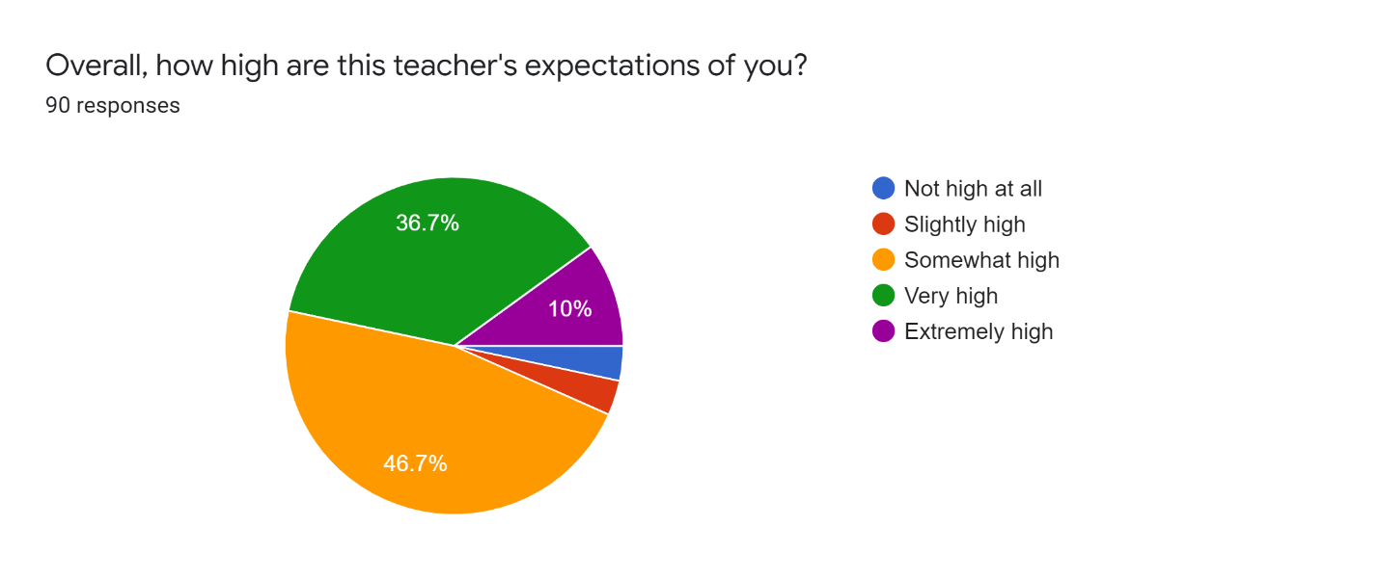
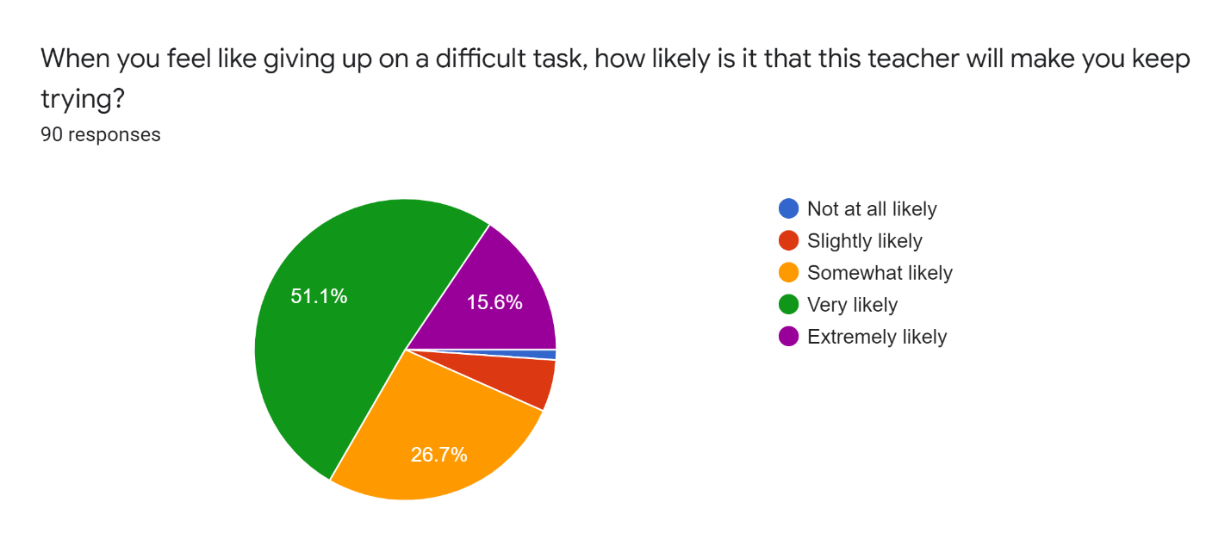
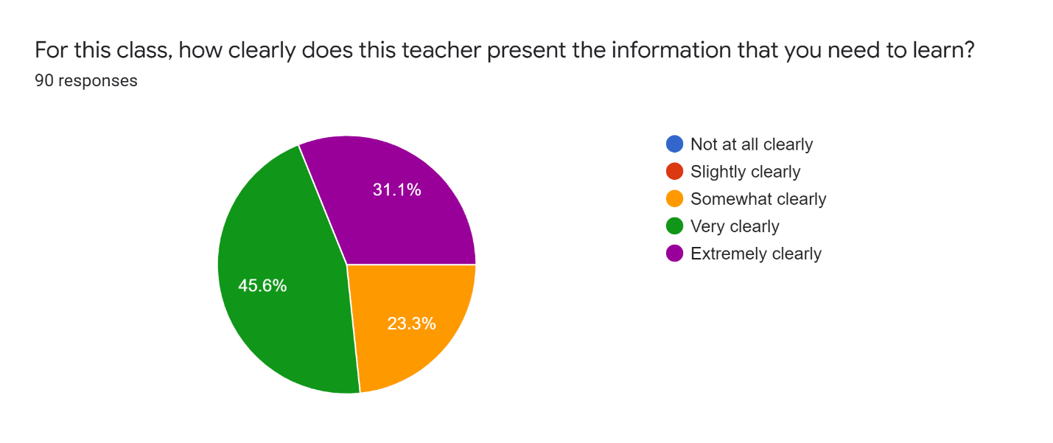
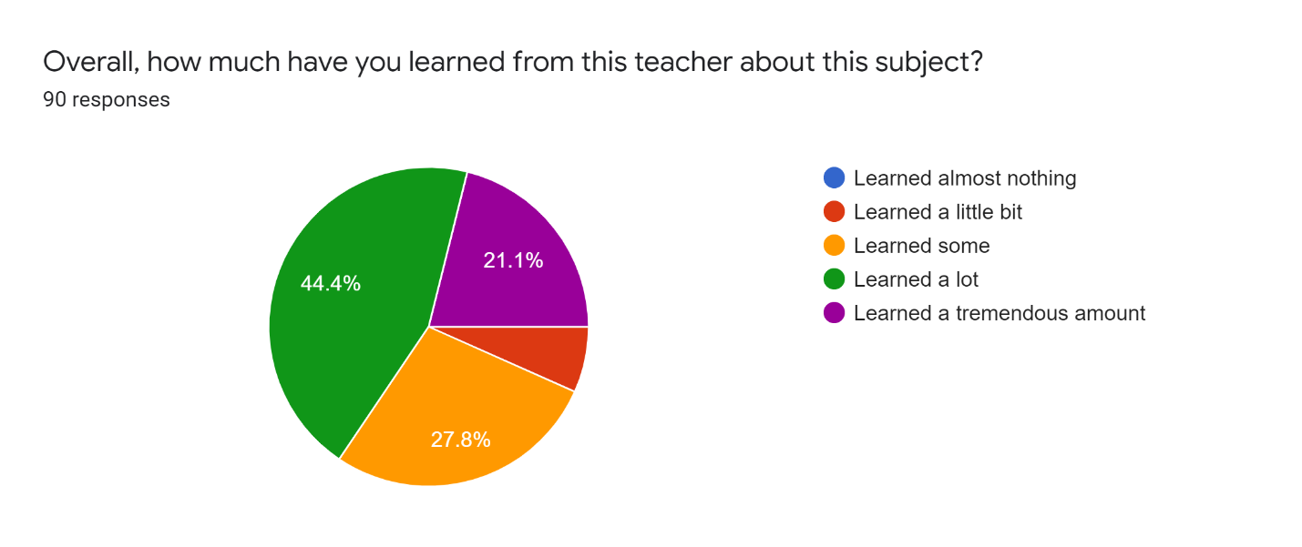

The Panorama Survey results were shared with completer and discussions occurred about the data how it could be used to positively impact future engagements with students. The information was also distributed to faculty to aid them in viewing how our completer(s) are impacting the landscape of P-12 learning.

Completer Effectiveness in applying professional knowledge, skills, and dispositions (EPP created Alumni Survey).

Alumni indicate varying levels of agreement in their preparation to create/implement engaging lessons which strongly impacts student learning and development. The charts below denote completer responses to several items which serve to impact student learning:

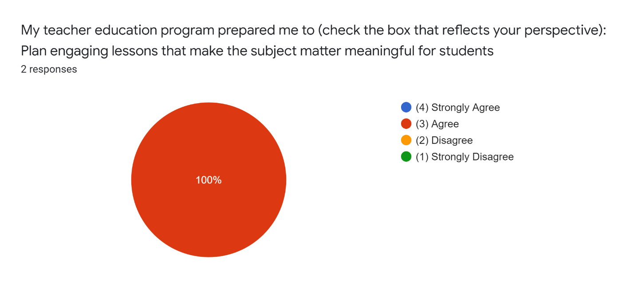

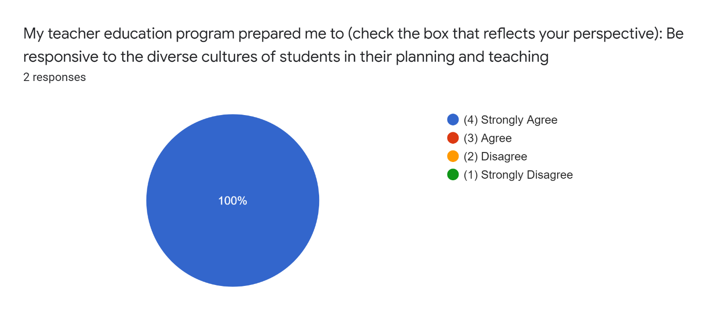
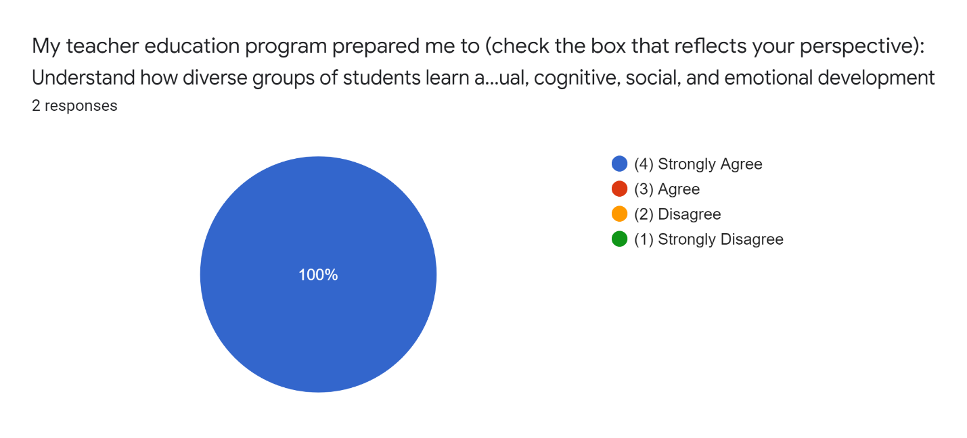

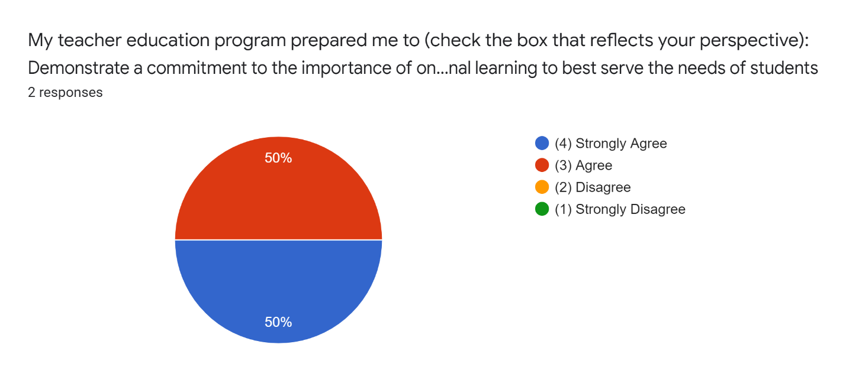
The EPP is pleased with the responses for the above noted measures. However, the low response rate does not provide a sufficient level of data to support programmatic review/revision. Ongoing efforts to improve the return rate are being explored by way of collaboration with other local EPPs and the WVDE to ascertain best practices in regard to completer participation.

Concluding Notes Regarding Completer Data
WVSU Education Department would be remiss if we did not acknowledge that the failure of the WVDE and HEPC to collect Transition to Teaching (TTS) and accompanying employer data is very disheartening in that it serves to underscore the difficulty in obtaining such information from graduates. The EPP is hopefully that the shift to Skyfactor for the collection of completer and employer data will prompt a greater return rate. Additionally, the EPP is working with the WVDE and other universities to explore options for expanding the level of participation for the initial level Alunmi Advisory Council initiative.

