**CAEP Accreditation**

The **Council for the Accreditation of Educator Preparation**(CAEP) accredits **West Virginia State University**. CAEP promotes excellence in educator preparation through content and pedagogy, clinical partnerships and practice, candidate recruitment, progression and support, program impact, and quality assurance and continuous improvement.  **West Virginia State University** meets rigorous national standards for educator preparation set by the **Council for the Accreditation of Educator Preparation**.

The West Virginia State University Department of Education received notice of a re-accreditation by the [**Council for the Accreditation of Educator Preparation**](http://caepnet.org/) (CAEP) from May 1, 2022-December 31, 2028.

The following programs were included in the CAEP 2021-22 Accreditation review:

**Initial Programs**: Elementary Education, Art, General Science/Biology/Chemistry, English, Music, Wellness, Business, Mathematics. (Endorsement areas: Reading and Special Education)

**Advanced Programs**: MEIL

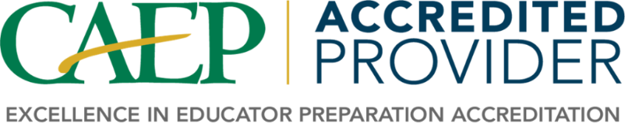

Council for the Accreditation of Educator Preparation (CAEP)  
1140 19th St NW, Suite 400  
Washington, DC 20036  
(202) 223-0077