To configure your computer to use Xerox Accounting and in order to print to Xerox machines, please do the following:
- Access Your Printers and Faxes Windows by either:
  - Click Start and then click on Control Panel:
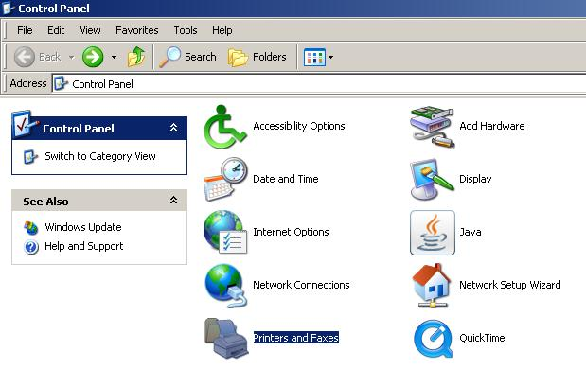
  - If you have the classic theme enabled (you do not see "Control Panel" in the start menu) click on Start -> Settings -> Printers and Faxes
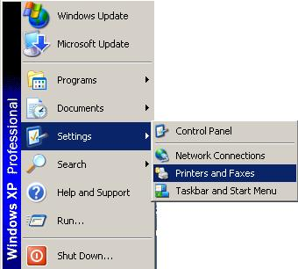
- Right Click on "Xerox WorkCentre 5645 PS" and click on Properties
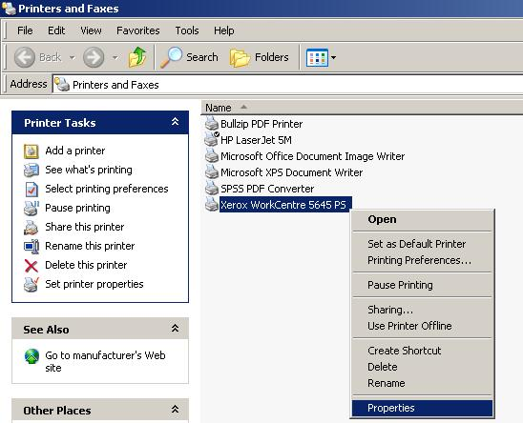
- Click on the Configuration tab
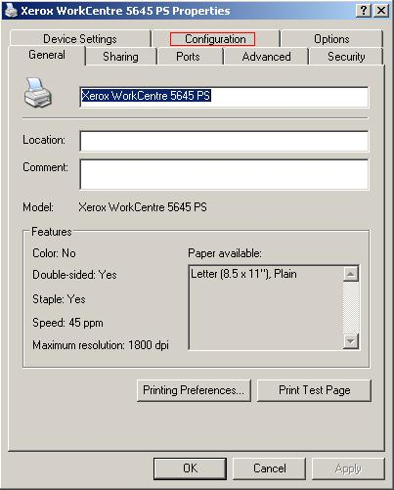
- Click on the "Accounting..." button
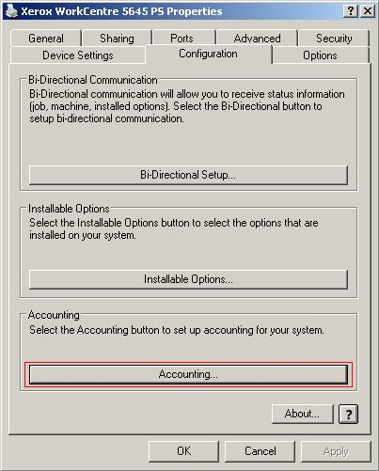
- The following window will appear:
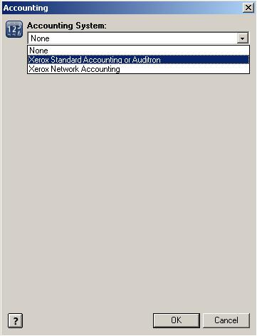
- Select "Xerox Standard Accounting or Auditron"
- The following screen will appear:
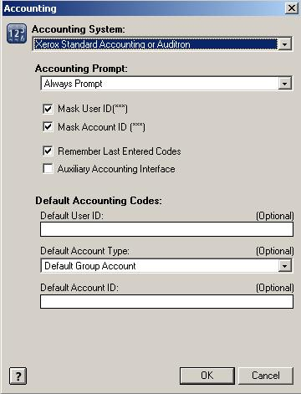
- Uncheck the "Remember Last Entered Codes" checkbox
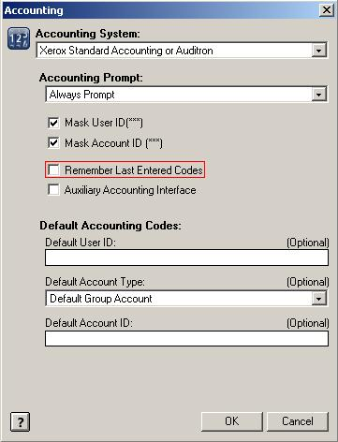
- From now on, every time you print enter your Copy Code:
