
Experience the Power of Education

PEER TUTORING
MANUAL

Mrs. Daisy Squirts, Academic Assistance Counselor
Counseling & Academic Support Services

Table of Contents
Introduction 2
The Most Important Thing 4
The Natural Human Learning Process 5
A Master Tutor 10
Does Tutoring Make a Difference 12
Tutor Family Values 13
Tutor unto others as you would have others tutor unto you.
The other important thing
The Goals of Tutoring 16
Promote Independence
Personalize Instruction
Provide Insight into learning
Provide a Student’s Perspective
Follow the Job Description
Expanding the Three PI’s 18
Promote Independence
Personalize Instruction
Provide Insights into Learning
More Tutor Family Values 23
Confidentiality
Respect
Attentiveness
First Tutoring Session
Walk-in Tutoring
The Bigger Picture
Final Word
Paperwork and Procedures 27
Writing Center and TAP Room Sign-in
Student Sign-in by Appointment
Absence Procedures
Daily Time Sheet
Tutor Pay—Paydays—Late Time Sheets
Appendix 31
Peer Tutor Job Description
Faculty/Staff Recommendation Form
Student Sign-in Form (Individual Tutoring)
Daily Time Sheet (Title III)

Polices & Conduct Statement & Evaluation 36
Welcome
Welcome to the West Virginia State University Counseling& Academic Support Services Tutoring Program. As a member of the tutoring team, you will be a valuable resource to assist tutees in being academically successful in college. Because of tutoring others, we hope that you will gain patience, self-confidence, and an appreciation for the academic struggles of college students.

Introduction

This manual is not a substitute for tutor training, but it does give you some guiding principles—what you’re supposed to be shooting at when you’re doing your job—as well as some knowledge, both theoretical and practical, about how to do it. Since you are going to be tutoring soon these topics should be of immediate interest. There is also information about procedures, policies, and paperwork, which makes for dull reading, but is necessary if you are to be paid, among other things.
You have probably done some informal tutoring and you have perhaps been told how good you were at it. That is nice; we all need encouragement (I hope you are seeing the humor in this). And, perhaps you did do a good job, or maybe the student thought he owed you something since you were willing to spend time with him—possibly the most unselfish thing anyone can do. Regardless what you have heard from others, or how much you know in your discipline, it’s astonishing how much you need to know to be even a mediocre tutor.
In order to improve you will have to practice these skills in situations that are not really practice at all. This will certainly make you uncomfortable, but will also insure that you will almost immediately begin to do a better and more credible job. Like most complicated interactions, however, no matter how long you are at it, you rarely get to the point when you can do it without thinking.
Despite your best efforts, however, some students will occasionally complain that you’re doing them no good. Since I have long experience at dealing with these students and never get defensive, I think to myself, “This ungrateful blockhead just can’t appreciate my skills.” Then I remember my training and offer a genuine apology, something like, “I’m sorry I haven’t been more help to you,” and wait to see what they say next. Their response to that usually allows me to separate those who want to improve their academic performance from the others who just want someone to blame it on.
Sometimes students will also say things that call for a response, but for which no appropriate words appear readily available. This will, by definition, be a surprise. What you say or do in this moment can have a huge impact on your relationship with the student (as well as with others within earshot). It’s not fair that we’re judged by a spontaneous reaction or otherwise thoughtless remark to a pushy or depressed or anxious or confused student, but these are precisely the times when character is most on display. Please bear in mind that you do not have to have a snappy answer to every question, accusation, protest, or pout. In silence is wisdom, especially when you are confronted with negative emotions. You do need to respond, but we will talk about that in class. Just do not take it personally if a student gets angry or frustrated with you. He may have a genuine grievance or only want someone to dump on. Either way, being a peer makes you a convenient, low-risk target. Do not be offended by the misplaced anger of your students. It is not typically about you.
Finally, do not worry unnecessarily about goofing up. Students bring a staggering number of misconceptions and expectations into the TAP Room or Writing Center or the Tutoring Room, so it is impossible to predict what’s coming. Just remember, no matter what, your fellow tutors and I will always love you because we have to. However, you will also be easier to put up with if your mistakes are within the bounds of program policies and purposes where, heaven knows, there is still plenty of room for all of us to go wrong.
The Most Important Thing
What is the most important thing about tutoring? Stop reading and think of at least one answer to this question: What is the most important thing tutoring does for a student?
If you thought about tutoring, you were doing the most important thing. It is what all good teachers and tutors try to get their students to do—to become engaged in the material, the content of the class. There are all sorts of preconditions to learning, so it is hard to say that one is indispensable, but, if you think about it, you will see that without student engagement learning is impossible. Emphasis should be on facilitating active learning to help students become learners that are more independent. Therefore, tutors are trained in techniques of collaborative learning. This means the tutor should not spend all their time in the front of the room lecturing students. Keep in mind that if they did not learn the subject matter from the professor’s lecture, they will not learn from your lecture.
Involvement in learning is how mediocre students become good students. Getting students involved with something so they learn it is the primary goal of tutoring. That is also the goal of education. So how do you get students involved? I have used personal experience, humor, potentially interesting issues, and even appealed to your own natural curiosity to get you engaged with what I have written in this manual. I used to require students to take a test on it.
What is the best way to get students engaged? Probably not lecturing or having them read manuals. We will talk about ways to do that in the training.

For now, answer this: true or false: All students are natural born learners.

About half of the students who go to college never graduate. Are academic deficiencies responsible for this? What else might explain the different levels of performance among students: motivation, self-discipline, use of effective learning strategies? OK, but most of those students who did not make it through college have learned to do complicated and difficult things elsewhere—drive a car, play the piano, or speak and write their native languages—sometimes without ever attending a class. In some situations at least, they seem to learn difficult stuff almost naturally. How are they able to learn so well in one situation, but not another? How do we learn anything?
The Natural Human Learning Process*
If you are good at something—playing an instrument, reading, writing, painting, driving, sewing, whatever—you went from not knowing how to do it to being good at it through practice, effort, perseverance, and the like. Just about any time you are involved in some activity you are learning. You can learn from typically passive experiences like lectures or TV, and you can learn from active participation in things like sports, music, or cooking. Anytime your mind is engaged, whether by listening, watching, speaking, playing, or doing, you are learning. These experiences are natural and continuing, regardless the setting. So, how do we do it? How do we learn?
The brain is an automatic pattern-seeking machine. Toddlers learn language by simply listening and discovering patterns. A child may say, “My mom goed to the store.” Even though he has never heard the word “goed,” he has learned to recognize a connection between verb endings and temporality—pretty amazing for a three-year old.
As he was listening to conversations, his brain was searching out patterns and connections. His brain actually created new connections among brain cells—neurons—in response to these discoveries. One definition of learning is the physical generation of these neural connections—dendrites growing or sprouting from cell bodies and hooking up with other neurons. We have about 100 billion neurons each with an average of 7000 connections with other neurons. A three-year old child has about 10¹⁵ (quadrillion) neural connections. We don’t need to figure out which dendrites need to grow or where they need to connect; our brains just do it—even the brains of students who can’t seem to do fractions. Remember that when you are getting frustrated with a student who is not catching on to something that seems so clear to you.
It will help your tutoring if you can also remember several inviolable and common sense rules that govern how our brains learn.

Rule number one: Dendrites only grow from what is already there.
No one can learn anything unless they connect it to something they already know. That is why a tutor might use pizzas to help a student understand fractions. The breadth and depth of a student’s prior knowledge of a subject largely determines what additional learning is possible.
Neural network number three below represents the body of knowledge and skills (learning) a teacher has set as a goal. There are many dendrites and connections among dendrites from several neurons. The first two networks represent students coming into the class with different levels of related skills and knowledge as indicated by the complexity of their neural connections.

Dendrites
2
1

Cell Body

3

Synapse between neurons

Network number two has knowledge and experiences that will enable him to “catch on” and develop the higher levels of knowledge represented by the more complex network. The first network, however, has so few related learning experiences that the lesson will probably be “over his head.”
The student who is less likely to succeed (neural network number one) is no less intelligent than the other, but only “dendrite disadvantaged.” He has not had the opportunity to activate the neural connections necessary for this new skill.
Rule number two: Dendrites grow for what is actively, personally, and specifically practiced.
Students who listen to a math professor’s lecture, but who do not also read and work problems, are not doing much to grow dendrites. The same goes for students who watch tutors work problems or listen to them talk about comma splices. Students may like it when you spend time doing those things, because that means they do not have to get engaged. Of course, they’ve already listened to lectures since they were in grade school; what makes you think your little talk is going to get through to them this time? Your students need to work problems and fix comma splices themselves.
Rule number three: Use it or lose it.
Students who stop practicing something will soon forget it. If you learned to play the guitar in junior high, but have not played in ten years, you will not be able to play very well the first few times you try it. The brain, like a conscientious gardener, will prune away unused dendrites.
There are several reasons why tutors need to understand this. Rule number one says you have to make a bridge from what a student does know—his prior knowledge—to the thing he does not know. As you listen to him explain what he is doing and why, you will often be able to diagnose where he got off track. When he gets lost, you think to yourself, “Which dendrites and networks need to be grown?” I like the concreteness of this. It helps you to identify particular deficiencies that are holding up the learning process.
Finally, you can simply explain to your student something about how the brain learns, for example, that dendrite growth depends on specific, personal, and active practice—rule number two. Neither you, nor teachers can grow students’ dendrites. This is one of the best ways I’ve found to place accountability for learning where it belongs without making students defensive.

Test anxiety
A student who has studied the required knowledge and carefully practiced the relevant skills will develop a complicated neural network for that material. However, what if he cannot remember any of this when he sits down for the test? The dendrites and synapses are there, so the memories are all present. What is the problem?
Chemicals produced by anxiety can get in the synapses and sabotage the brain’s ability to think and remember. This is rooted in our survival instinct. The student cannot run, so he freezes (in a manner of speaking).
On the other hand, if the student is curious and looking forward to the challenge, “happy chemicals” are released that facilitate remembering, which leads to:

Rule number four: Emotions (and their associated brain chemicals) affect learning.
This is why tutoring should be a safe activity for students. You cannot control the negative or positive associations students may bring to the subject, but you can work to make your time with the student a positive, even enjoyable experience.
Very early in the tutoring sessions give students low-risk tasks so you can see where they are and help them build confidence. Smile a lot. If the student leaves the tutoring room and feels good about himself and you, even if he did not learn much math, he will likely come back for additional help. He will be more disposed to receive your help. You can verify this by remembering how you felt about those teachers who taught you the most.
NOTE: Smiling, for some of us more than others, takes regular practice. Just as the other skills involved in tutoring, you have to consciously work on something as seemingly simple as smiling as you are working with students.
Tutoring and Correction.
When students make mistakes, most tutors want to correct them immediately. Effective tutors resist this natural desire, particularly early on, because so many students are likely to see correction as criticism. As a result, some students will withdraw and others will become resentful when you correct mistakes (you can hear this in the tone of their voices). Neither of these attitudes is conducive to learning.
Pointing out mistakes may also be a confirmation of your student’s academic insufficiencies. They do not need any confirmation on that score, so try being quiet (a most unnatural tutor behavior). See if your student can catch his own mistake. On the other hand, you might say, “What’s wrong with what you’ve said here?” This may certainly be taken as a type of faultfinding, but at least it engages the student as a partner in the process, and reduces defensiveness. Avoid treating the student as a passive recipient of your correction; draw him into a dialog about the sentence or problem or whatever.
Recall how you might talk to yourself while studying difficult subject matter:
“Am I on the right track here?” “Do I need to see an example?”
“Should I slow down?” “Am I using the appropriate strategies?”
This inner dialog shows how you monitor your own efforts. Poor students lack knowledge about themselves and the effort required, and do not maintain the motivation and determination to persist despite distractions. Teaching students to ask these self-regulating questions, as they are reading, writing, or working problems, gives them an indispensible skill. So, do not be so quick to pounce on mistakes; let students flounder a bit. They do not need mental handouts, but guidance with the struggle and work of learning. Both the student and tutor need to sweat a little. Remember ENGAGE THE STUDENT in the learning process.

Good tutoring is more like a conversation than a lecture

A Master Tutor

One of the best teachers I ever had was a seventy-year old tennis coach who had undergone a laryngectomy. He talked through a microphone that he held under his chin. Before we went on the court he told me several things I should try to do. Then we spent the next hour hitting. Since he could not say anything with his hands full, we rallied in a silence broken only by the sound of the ball on racquets and my labored breathing. Once, at the end of a long rally that I finished by cracking a hard, deep, backhand out of his reach, he stopped, smiled, and extended his arms as a celebration of my momentary triumph.
In his younger days he had been on the Czechoslovakian Davis Cup Team, and I don’t suppose any of his students ever played as well as he, but he got them to play as well as they could. What I liked about his teaching was how competent he made me feel. He did not shake his head when my footwork was sloppy, but said, without words, “See what you can do!” when I did it right. In addition, when I saw what I could sometimes do, I began to believe in myself. Afterwards, when I went out to play, I expected to hit good groundstrokes. Sometimes I did.
Much later on, I coached State’s tennis teams for a few years. I knew I could tell players all sorts of important things but, if they were going to learn, they had to get out on the court and hit some balls. I did spend time correcting deficiencies, but I also looked for what players were doing well, and encouraged them with that.
I occasionally fell into the habit of having players watch me, since unfortunately, that’s the easiest thing for any coach to do—”See, like this!” Moreover, I regularly see tutors standing at the board patiently and clearly explaining a math or chemistry problem for the second or third time. What do you imagine your students are thinking about during these demonstrations?
“So that’s how it’s done! What a wonderful explanation. This guy should be teaching our class!”
Or, maybe it’s something else:
“This guy sounds like my teacher. I wish I knew what he was talking about.”
“Gosh, she’s really smart. I’ll never be able to do that in a million years.”
“How long is he going to go on, I’ve got to get some help with this homework.”
“I already know how to do that, I just don’t know when to do it!”
“He must think I’m a dope. He’s right! I am a dope--I’ll never get it.”
“She’s so cute. I wish she’d smile more.”
“I wonder if they’re having poppy-seed chicken in the caf today.”
That is not encouraging, but you have probably been there yourself and know it is not so far-fetched.
So, what is a tutor supposed to do—get students to the board, let them flounder around with problems, and hope they will do something right so you can encourage them? We will addressed the answer to this question in training, but yes, you do need to provide a safe place for your students to struggle and make mistakes. We all had to do that before we got to where we were good at it. In addition, difficult problems are not always immediately obvious to even the best math students. They understand that floundering is often a prerequisite to successful problem solving no matter what the level of math proficiency.
On the other hand, it may come as no surprise that many students with poor academic backgrounds believe that learning should be quick and easy. They assume good students catch on quickly. Since learning for them is not quick and easy, they must be poor learners—at least in that subject.
These students do not realize that struggling and working hard are typical for most students who excel in any academic discipline. That’s why tutors should never say, “Oh that’s easy…” Hitting a forehand, playing Stairway to Heaven, or graphing an equation is easy only for those who have spent hours practicing.
As you are tutoring, it is important to understand clearly and unsentimentally the real nature of the difficulties you face. The student has to grow the dendrites and make the appropriate neural connections. If he does not, it is not directly because of his teachers, tutors, or textbooks, but because of something he’s not doing. Of course, teachers and tutors need to give him opportunities to do things that will teach him how to learn and make the proper neural connections.
There are all kinds of real barriers to learning, but most of these are natural; everyone has to confront and overcome them. The brain learns naturally, according to a few simple and obvious rules. With proper guidance, students are capable of more than we might expect. More importantly, they can learn more than they expect as well. A tutor’s job is not to correct a paper or explain a math problem, but to help students become better writers and problem-solvers. You are really not English, math or biology tutors, but rather learning tutors.
Does Tutoring Make a Difference?
Although most people assume tutoring is a good thing, we collect a variety of data to determine if students who have tutors or go to the TAP Room actually do any better academically as a result. For example, students consistently give peer tutors excellent ratings on written evaluations. Over half indicate they would have failed or dropped their classes without tutorial assistance. They estimate that their class grades improved an average of one grade letter after beginning tutoring. Again, this is only their estimate, but it is positive. Therefore, students say they are getting something out of tutoring.
Most studies, which look at the effect of tutoring, indicate that grade improvements are connected to the frequency of attendance. The more students receive tutoring the greater their competency of the subject by the end of the semester. Studies show there is a clear, strong, and positive correlation between tutoring and final grades. Feel free to share this with your students.

Tutor Family Values
Several years ago, I asked tutors why West Virginia State University would go to the considerable expense of providing tutorial services. From this discussion, we developed a list of core values that provide a moral foundation for the Peer Tutoring Program. This list was eventually distilled to the one, famous Aretha Franklin value that encompasses most of what we should be guided by: R-E-S-P-E-C-T.
Though we all acknowledge that respect is good and necessary, we do not always act consistently respectful despite our belief. In other words, we know how to be better people than we actually are. In fact, the late Pope John Paul, II said that is the challenge of our lives—to surrender the person we are to the person we know we ought to be. The emphasis here is upon our own intention and effort, as opposed to divine intervention (as indispensable as that may be).
It is not sufficient to have good moral sentiments. If we are serious about meeting the challenge of being respectful then we must know the specific kinds of behavior that characterize respectful people. Here is a partial list of those characteristics:
- being punctual
- smiling
- using students’ names
- listening
- knowing your subject
- practicing the skills that encourage learning
- maintaining confidentiality
- holding students accountable
- being honest and saying “I don’t know”
Nothing new or controversial here. Everyone likely agrees that these are examples of proper and respectful behavior. However, this behavior does not come naturally, but must be learned over time. No one is born punctual; none of us arrives at work on time accidentally. Rather punctual people are those who conscientiously practice punctuality by getting proper rest, maintaining reliable transportation, and so on. Tutors who show respect for both their employer as well as the students they serve will make it a priority to be consistently punctual. The same thing goes for the rest of the specific ways tutors demonstrate respect—like all learning, they must be actively and specifically practiced.
Sometimes tutors say that training makes them self-conscious with their students—redirecting students’ questions rather than answering them, listening instead of talking, and so on. They may think (without really thinking) that self-consciousness is a discomfort best avoided. I am always gratified to hear their practice of good tutoring techniques makes them uncomfortable. Every skilled tutor was, at one time, an awkward beginner. Remembering this will help you be more patient with yourself and your students.
Tutor unto others as you would have others tutor unto you. This is a paraphrase of our guiding principle. If you think about what you would want in a tutor, you can begin to see a standard for your own practice. This covers a lot of ground, but it is mostly about giving service—everything from listening to a discouraged student to making coffee.
Even if you are dedicated to being respectful in all the specific ways that have been mentioned, it should go without saying that you will not always be respected. One of the marks of a truly respectful person is that he gives respect, even when reproach may seem to be a natural response. When students say or do offensive things, a good tutor remains respectful. Tutors need to recognize that students and others will inevitably behave in ways that might, in other circumstances, call for some sort of righteous indignation. Most of us retaliate when we are offended, but there is a better way.
If you will count the number of times you have negative thoughts about other drivers as you are coming to school, for example, you will begin to see how easily irritated you (and the rest of us) are. If you are like me, you will think things like this: “Why is she going so slowly?” “Is he going to turn or not?” “I wish she would back off.” “I’ll bet that guy’s going to pull out in front of me.” “The light’s green already!” All this during a two-minute drive.
I am not suggesting that we have no reason for such negative thoughts; in fact, they may be quite justified. People do drive slower than we want, they do not use their blinkers, and all this is quite annoying at times. Nevertheless, what would it take for me to simply ignore all these and similar offenses? Yes, only a miracle, but we can at least be willing to be different. We can want to change from a critical, complaining, and self-righteous person, to someone who is more generous and forgiving, and who spends less time counting offenses and asserting rights.
No one ever became a better tutor (or person) by accident. Will and intention are indispensible. We have to practice being the kind of tutor we would like to have.
The other important thing. Do not forget that as an employee you are also paid to give your time and energy and some measure of devotion to the students you serve. You may enjoy it so much that you would do it free, but the job is still a commitment no matter how you feel about it.
It is nice that most tutors like what they do, but being a Peer Tutor is primarily a responsibility. Sometimes you will enjoy being helpful, but you will also experience discouragement and disappointment. Tutoring may get in the way of other things you would rather be doing. You may want to end a session early or leave the TAP Room before your time is up, but your responsibility is to serve your students.
Within the bounds of the job, tutors will regularly have to put the needs of their students ahead of their own. Please think about this before you commit, since it is a problem when tutors cancel sessions or have to quit in the middle of the semester. After you have thought about the time and effort required, and you still want to become involved—wonderful. If you are ready to serve your classmates in this way, you will certainly find the experience to be challenging and rewarding.
The Goals of Tutoring*

Even if we understand some of how our brains learn, the rules that apply, and the conditions required, learning still remains a complicated and dubious enterprise. In addition, teaching—even excellent teaching—is usually characterized by an uneven, hit and miss, stop and go, off and on progression of activities, discoveries, and disillusionments more appropriate to gambling, fishing, or some other improbable adventure.
I have often said, somewhat inaccurately, that tutoring is not teaching. What I have meant is that tutoring is not what most instructors do when they are teaching classes. Tutors and teachers are both trying to engage students, but they have different roles and somewhat different goals. As a tutor, you should recognize that you have a limited number of things you want to accomplish. If you keep them in mind, they will guide you with your students—particularly on those occasions when you seem to be getting nowhere.

1. Promote independence. Teach students to do what you have learned to do. Model how you taught yourself. Explain the strategies you used successfully. Show them what you do when you do not know what to do. Don’t you wish someone had told you this stuff?
2. Personalize instruction. Students do not need another great lecture on the supply-demand curve. They need to see how to relate this new concept to something they already know (dendrites do not grow out of thin air you know!). Use examples that are relevant to students—and particularly examples that this particular student sitting beside you can relate to.
3. Provide insight into learning. If they are to think critically and go beyond memorizing facts, students will need to know something about how learning actually occurs. Remind students of the demands of higher-level thinking, and help them to make the required neural connections. Spend time explaining how they can grow dendrites. After all, you are a tutor—you know the rules.
4. Provide a student’s perspective on learning and success. Parents, teachers, and friends are telling students what they should do and why; but students need to think through these issues for themselves. Help them find a purpose or goal that goes beyond reading chapter three. Probably the most important question a student can ask himself is, “Why am I here?” Until students can give a thoughtful answer to this question, their college experience is a little like going to Subway to get their card punched. They may accumulate some credit, but where’s the focus and drive and inspiration? Most students can’t keep up the hard and long work of college without having a clear idea of what it’s all for.
- Follow your job description. Your work will affect, for better or worse, the lives of your students, so it is an important job. Moreover, you are paid to provide these services. The job description gives you an idea just how broad the range of services is (see the Appendix, pages 34-35).
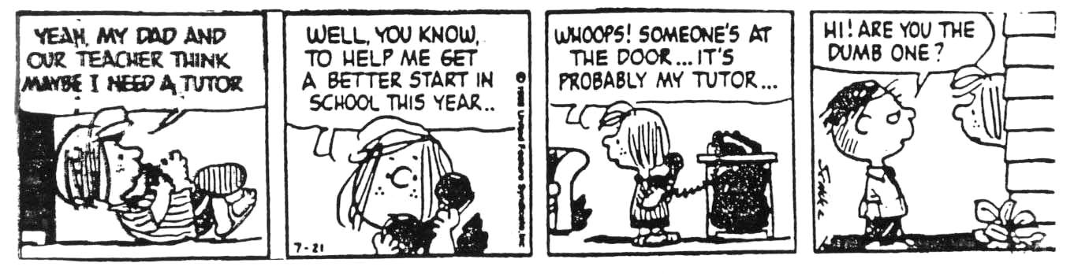

Expanding the three PI’s

Promote Independence. Despite years of competent instruction, many students still have trouble doing fractions and writing grammatical sentences. On the other hand, you can do those things; so how can you help students do what you have learned to do? First, Natural Human Learning Rule Number One: dendrites only grow from what is already there. In order for us to learn anything new, it must be connected to something we already know. How can you do that?
Eventually you want your students to tell you about their academic difficulties. They may be very clear about this, “I can’t do order of operations.” Or, and this is much more likely, they may not be entirely sure about where they went off the track or what they need to do at this point. In any case, you need to discover what they know and what they can do.

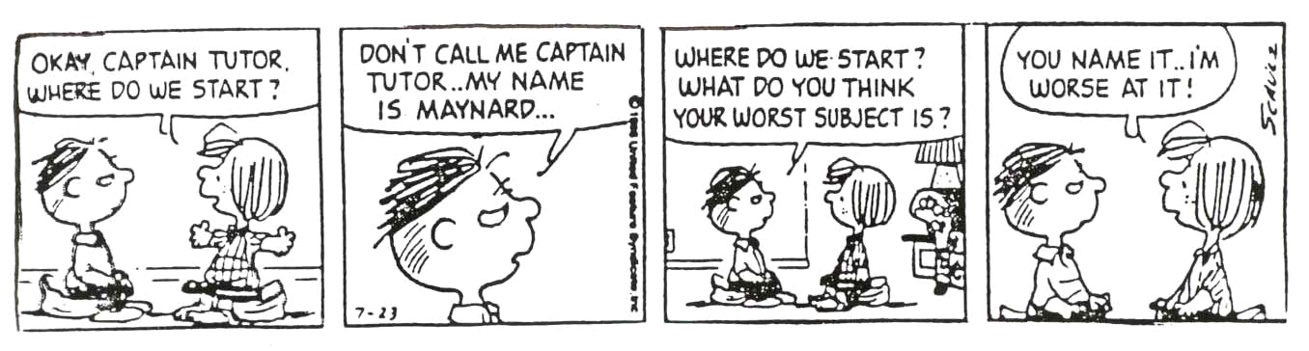

What dendrites for this skill have they developed? The only way to determine that is to look at your students’ work—or better yet—observe them doing math problems, writing sentences, or listen to them explain mitosis. If you do not understand what they know and why they are doing things, it is nearly impossible to know where to begin helping.
For example, if order of operations is the presenting problem, do not go the board and give them a wonderful example of how to use “Please excuse my dear Aunt Sally.” Rather, ask them if they can demonstrate a prerequisite skill, like the rules of exponents or adding signed numbers. Keep going until you find something they can do; then you can help them take the steps from this knowledge to the thing they find unclear.
This is easier in naturally progressive subjects like science or math, but you can ask about anything: the composing process, court cases, or the roles of management. Start where you think your student can function well and move on to the more difficult material.
Important Point: Do not act like an instructor quizzing a student. This process of finding out where to begin is not a test but a conversation. You are encouraging the student and providing an environment secure enough for him to explore what he thinks. (By the way, you may not realize it, but this is asking a lot of you both.)
Also, remember that many students are not clear about what they need to know, nor are they entirely convinced about those things they actually do know. As you explore their prerequisite knowledge and skills, help them gain the conviction that they do know, and can do some things. Once a student is convinced he can add two signed numbers by using whatever procedure, he will be much more disposed to learn subtraction. You may offer your own good explanation of how to do that, but success depends upon the student’s confidence in his own knowledge. Without this self-confidence, students almost never perform well academically. That is why they are much more likely to want to watch you. Get them engaged so they will come to believe in themselves—with conviction!
You probably know, from your own experience, how natural it is to agonize about what you are doing in Math or English. Students often think the rules are fickle, truths are temporary, and what was right and good yesterday will be very different today. As they are writing or doing math problems, ask what they are thinking or what rule they are following. You cannot read their minds, so you have to ask them why they are doing things. Ask them to “think out loud” about Federalism or how they solved a problem. This will help you understand where their thinking is on track and where it is fuzzy.
By they way, when you ask someone what he thinks, you must ask firmly, as if you really expect an answer. Most students will resist telling you what they know or what they are thinking because they may not have a clear idea. On the other hand, maybe they are afraid that what they think is wrong or insufficient, and perhaps shamefully so. Most students are much more comfortable letting you do all the talking and explaining. Nevertheless, you have to know what they are thinking—both when they are shaky and uncertain and when they are accurate and confident.
Be sure to ask students why they are doing things when they are doing them correctly. Students do not always know they are right, or maybe they do not know why they are right. When they can explain why this is a complete sentence or how they got a correct answer, you know they are beginning to develop a realistic confidence in their own abilities. If you only ask questions when they mess up they’ll catch on and clam up.
Finally, since you are going to be asking your students to explain what they are thinking, you have to be prepared to listen to them. The first thing is to be quiet—even for a whole thirty seconds while they are trying to respond to your question. Look at them, and keep quiet. Nod your head and say “uh huh” a lot. Encourage them to keep talking. Keep listening and do not interrupt when they say something incorrectly. Help them talk it through.

Just as students need time to get their thoughts together before they respond to a question, they also need some time after they give an answer. So, when they do respond to your question, right or wrong, do not say anything. Keep quiet a little longer. This gives them an opportunity to reflect on what they have said, and perhaps expand or revise it. Do not be quick to correct students when they are wrong or compliment them when they are right. This is an astonishingly difficult thing to do. Maybe this quiet waiting requires a kind of self-consciousness. I have certainly never gotten to the point where I can do it naturally (without thinking).

Make the tutoring session a secure place for students to express their doubts.

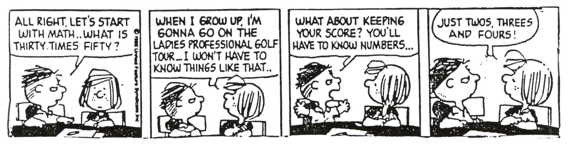
Of course, as you listen to students talking (and wait while they are thinking) about the subject, you will get an idea of where they are going right or wrong. Sometimes, wonderfully, they will too. You can help them revise their mistaken notions, confirm, and reinforce correct thinking. However, you will not really know what they know or do not know until you get them to demonstrate or explain it to you. Even when they know they are lost, some students do not like exposing how lost they are. They have to trust you and believe that you will deal with their lostness gently.
Your own expressions of confidence in your students and encouragement for their good work are among the most helpful things you have to offer—so do this from the very first minute. Once students gain confidence in themselves and what they can do, they’re on the road to becoming independent learners. In addition, you, if you are wildly successful, will have worked yourself out of a job—with this student anyway.
Personalize Instruction. Connecting what students need to know with what they already know often involves using examples, analogies, and activities that illuminate new territory by comparing it with the familiar. Accounting tutors may use the example of a five-dollar debt to help students understand postings. Since all students know what a quarter is, math tutors can use money to talk about fractions. Students who have pets can understand the concept of classical conditioning by relating it to what happens when they feed the dog or goldfish. Tutors, unlike classroom instructors, have the advantage of using their students’ own unique backgrounds, knowledge, and experiences to make learning accessible.
However, Peer Tutors can only do this if they have taken the time to ask about their students’ prior experiences and have been patient enough to pay attention and remember what they have said. That is why shooting the breeze is a good use of your time, particularly at the beginning of sessions. It’s not just idle chatter, but an opportunity to gather critical information that good tutors use to facilitate the learning process.
Of course, learning is more effective when students are motivated. I did not have trouble studying the learner’s driving manual before taking the test because I really wanted to drive. However, the same motivation is often missing for students enrolled in biology or math classes. Help students find a reason why they should learn biology and math by connecting coursework to their personal goals. Ask them why they are in college. If the focus is upon a burdensome class rather than their goals, performance will suffer and you will both be miserable.
NOTE: Some students may not fully understand the connection between effort and rewards. Maybe they have received grades they did not earn, and expect to continue receiving them because they are desirable rather than deserved. Of course, that is a fantasy that can’t continue.
Do not get sucked into the victim mentality. Do not commiserate with students who try to rationalize or excuse their failures. Until they learn to accept the fact that what happens to them is a matter of their choices more than their circumstances, they will continue to be miserable.
Provide Insight into Learning. Many of us have, or have had, goofy notions about learning. Some were mentioned earlier—that learning should be easy and quick, that some people are naturally good at math or English, or that learning is memorizing. As a tutor, you cannot always deal directly with beliefs that are barriers to learning, but you can help students to be better learners by tactfully disputing mistaken ideas when they crop up.
You can also have an impact on your students’ study tactics and strategies. Ask some students how many hours they studied last week and many will not have a clue. Often they are not organized, disciplined, or sufficiently self-regulated individuals. This is an opportunity to teach them something that has credibility. Tell them how you did homework, prepared for exams, planned you study, and so on. Demonstrate the strategies you have successfully used. Suggest things that made a difference to you when you were in that class. The next time you see these students; ask if they tried your techniques. Let your disappointment show if they tell you they did not do any of this stuff, but do not ask them why they did not do it. They will just have to make up something since they really do not have a good reason. However, do ask them what it will take for them to get on with this. Wait for an answer and ask about that the next time you are together. If students aren’t doing something to help themselves when you’re not around, what good is an hour or two of tutoring going to do?
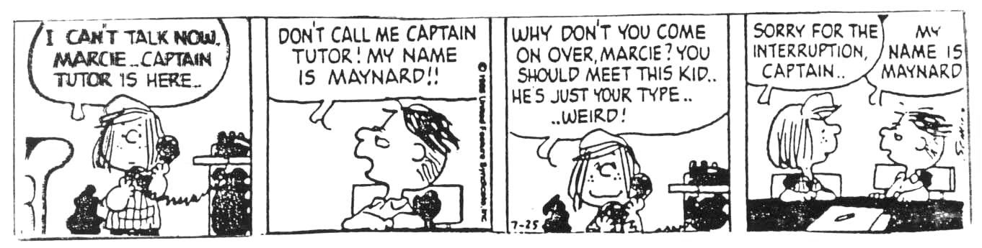

By the way, if students think that you are some sort of natural superstar, they will not have any good reason to change their learning strategies. They think you get good grades because you are smart, not because you study smart. If they were smart like you, they would be getting good grades too, so they think changing their approach to learning is not really part of the equation. Do not let them get away with this.

More Tutor Family Values

Confidentiality. Whatever goes on in your tutoring session is no one else’s business. As a paraprofessional you have an ethical responsibility to maintain confidentiality with each of your students. This means you do not discuss students with your family, your teacher, your students’ teachers, other tutors, friends, acquaintances, or strangers. You certainly ought to strongly encourage your students to meet regularly with instructors, but you should not take it upon yourself to speak with their instructors. You also ask the student to get clarification about an assignment, for example, and help them get over fears about seeing faculty members, rather than doing it for them. Faculty members are usually quite pleased to know that any student is being tutored, but students may have the idea that getting help is something to be ashamed of. They are wrong, of course, but until you convince them what a common and good thing tutoring is, they may simply want help without everyone knowing.
NOTE: If a situation arises that you need help with, you can see me about it, and I will also maintain confidentiality. Other tutors may also be able to assist you—just do not use names. In addition, a thoughtful tutor respects a student’s confidentiality by not coming up to him when other people are around, and saying, “Hey, what grade did you get on that paper we worked on?”
Respect. Confidentiality is a professional requirement of all those employed in the helping fields. I have no choice about the ethical demands of my profession; they are enforced like laws and sanctions are imposed for transgressing them. Respect, on the other hand, provides a moral foundation for what helpers do—or at least a part of that foundation.
If you have ever been disrespected by a teacher or other helper, you know how damaging that can be. There is no substitute for having a good relationship with your students. Being friendly, smiling, and demonstrating respect to your students goes a long way to making you a successful tutor. Without those, even the most brilliant student with glowing recommendations will likely be a lousy tutor. (I know I have already said this.)
Attentiveness. Listening is perhaps the most basic and regular thing you can do to show respect. The best way to practice listening is to keep quiet much more than you are probably used to doing. We have already talked about waiting after asking questions and after getting answers. You may not have many neural connections for that now, so you will have to consciously practice being quiet and listening.
As a helper, one of your initial challenges is to give all students an opportunity to tell you why they are there. Start with open-ended questions: “So, how’s your semester going?” Ask more specific questions if they give only general answers: “Tell me about your English class—how’s that been?” Be patient when they do not give clear and complete answers. Rather than asking a lot of questions, first nod your head, say “uh huh,” and keep quiet. Students do not so much need detectives to ferret out all the details, but good listeners who will simply encourage them to explore what is going on.
One way to check out your understanding is to paraphrase what you heard. If you are off base (or if the student changes his mind after hearing you) he will try again. Learn to bear silences. Give students a chance to think. This is very difficult, especially since you may know exactly how to explain whatever it is he’s stewing about, and are probably itching to give him your little lecture on it.
First Tutoring Session. If this is an appointment, be early. You will know the names of your students, so be sure to greet them by name—another mark of respect. If you have more than one student, introduce everyone. If you are in the TAP Room or Writing Center, show up when you are supposed to. Get acquainted with your students. Make small talk. Smile. As always, begin with open-ended questions: “How’s it going?” Help them log in if they need it. After a little conversation ask how they are doing in the class they came to tutoring for. Listen. Make sure every student gets a turn, then plan the session around their needs, tell them how you would like to proceed, and ask if that is OK with everyone. You may decide to work with one student while others work on their own, or you can work with them as a group, even though it may be a review for some.
Look at homework. This is a great way to find out what they know and what they do not. Look at class notes. Offer suggestions (“Be sure to read each of the chapter sections, and then do the practice problems before you go to class.”) Ask one who can already do common denominators to do a problem on the board. Alternatively, ask the one who cannot do common denominators to do one on the board as far as he knows. Again, do not jump on the first mistake. Let him work at it, even stew a bit. Let the others work on it as well. Ask any of them what they are thinking about, how they are making the decisions they are making.
Do not feel like it is your job to rush in and fix everything. Encourage everyone to contribute—to get engaged and think. Tell them what they are doing well, even when what they are doing isn’t entirely correct. Find something that indicates the student is thinking and trying. Encourage thinking, not memorizing. If you make a mistake doing a problem, admit it immediately. (Tell your students—with obvious sarcasm—that you did that on purpose to see if they were paying attention.)
Encourage students to go to class and study regularly by explaining how those things made a difference for you. Let them know if you see an inconsistency between what they say they want and what they are actually doing. Do not do their homework. Do not think for them. Do think about what you do before you do it. Tutoring does not come naturally, so keep the goals in mind and let someone else know how it is going. Make this a good learning experience for yourself as well as your students.
Toward the end of a session suggest things for students to be doing until the next time and make a note or remember it so you can begin there when they return. Before the end of a session try to provide some sort of closure for students:
- an informal quiz that deals with the important ideas discussed
- ask what they think is the most important concept covered
- if they could only take home one idea from the session what would it be
- ask students to predict what they think the next lecture topic will be

Walk-in Tutoring. Tutors in the Writing Center or TAP Room will not necessarily know who the students are who come in and want assistance—at least not at first. You do not need to introduce yourself formally to everyone who comes in, but you should try to notice new arrivals, make eye contact, and smile even when you are working with another student. Make the students feel comfortable and welcome. Usually there are several students present, so you will have to circulate. Avoid sitting down and getting comfortable with one student or group in the TAP Room. You may think you have only been sitting with a student for a few minutes, but five minutes can seem like an hour to another student who is waiting for help. Be fair as you can about how you distribute your time among the students.
The TAP Room and Writing Center should both be relaxing and friendly places; they are also professional offices and places of business. Don’t act like you are in your living room, or students will feel like they are interrupting you and your friends. Welcome strangers; do not treat anyone like an intruder. Again, this is not natural, so you have to think about it throughout the day. You want your students to start to feel as comfortable there as you do.
The Bigger Picture. As a Peer Tutor, your job is to help students succeed in school. Normally this means helping students with the content of the class—reviewing, using alternative explanations, giving examples, going over the content, creating sample test questions, directing study, teaching learning strategies, and so on. We will talk about that during training. There are, however, many things that get in the way of success in college that aren’t “academic” in nature: having no clue about a major course of study, getting fired from a job, illness, kids, the car won’t start, you name it.
Regardless the nature of the problem they are having it is still your job to help students be successful in college. You are not a career counselor, marriage counselor, grief counselor, or auto repairperson, so you cannot be expected to do the actual helping in some of these situations. However, you can listen to whatever is bothering your students and get them to someone who can help. That is called making a referral. Ask me or any other Counseling Center staff if you are not sure what to do or where to go with any specific student issue.
Final Word. Remember that you are a student, not an instructor. You do not lecture, give tests, or grades. The instructor is the primary source of information for the class. You are a helper—a very important person—but you play only a supporting role.
Since you aren’t a know-it-all, don’t act like one. You do, however, have a lot of influence. The main reason Peer Tutors are so effective is because they are peers. Since your students see you as someone a lot like themselves, you are credible, and they are likely to pay attention to what you say. They are also likely to act on what you say as well (so be careful).
Finally, if you do not know something, just say so. That may get you more credibility with your students that all the brilliant things you do. Besides, you are not the answer person. If a student asks a question, whether you know the answer or not, you can redirect the question: “What does your text say about that?”

Paperwork and Procedures

Students who request tutoring by appointment complete a short application that includes the hours they are available for tutoring. I often try to match up several students in the same class (other than English or writing) with one tutor. Usually you will not have more than three students. I’ll call you for your first appointment, and put a copy (yellow) of the appointment slip in your folder on the desk in the Tutoring Room (111 Sullivan Hall, East). After you begin coming to the Tutoring Room regularly remember to look in your folder for other appointments, messages, etc.
Writing Center, TAP Room, and other walk-in tutors, have specific hours to work, though sometimes they will have tutoring by appointment in addition to their regular walk-in hours.
Writing Center, TAP Room, and Foreign Language Lab Sign-in. All students swipe their student IDs as they enter and leave the tutoring centers. This creates a record of attendance. Tutors must also use the computer sign-in upon entering and leaving. This will give a record of your working hours. There is a hard copy of a tutor sign-in sheet that you may use for your own convenience, but your actual paid hours are determined by clocking in or out on the computer.
Student Sign-in (by appointment). Other than TAP Room, Writing Center, and Foreign Language Lab students, tutors will have their students sign in (Student Sign-in Sheet) every time they come for a tutoring appointment or show up for a regularly scheduled group session. Put your name at the top and have your students print the date, their names, and the class. (See a copy of the form on page 41.)
This is not usually a problem for individual appointments, but it is easy to forget when students are coming into a group session at different times. The information is used for reporting and research purposes so tutors need to make a special effort to insure that all students’ names are on these forms. Also, I usually do a report that compares attendance with final grades. I do not report names, but I do need to know how many times each student attended the group session. Do not worry about how long any student stays. If someone shows up, have them sign in. Submit the Sign-ins with your Daily Time Sheet (see below).
Absence Procedures. Tutors are required to wait fifteen minutes for students who have appointments. If they do not show up within that time tutors may leave. If students call the office to cancel I’ll notify you, or at least put a note in your folder. Students are considered unexcused if they do not let you or the Tutoring Office know at least one hour in advance. That means a student who walks in, says he does not need any help, and leaves is unexcused. He could have told you that yesterday and you would not have made the trip in for nothing.
Leave me a note when any student has an unexcused absence. After two unexcused absences I’ll notify the student that sessions are cancelled and remove them from your schedule. If they show up to a subsequent session tell them to see me about getting another appointment. Any student who has a reasonable excuse will be given another appointment and reinstated, but you do not have to make that decision.
If you do wait fifteen minutes for a no-show, you may claim thirty minutes on your Daily Time Sheet. Tutors are not paid for excused absences.
If you are going to be late for an appointment or your shift in any of the walk-in tutoring locations, call the Academic Assistance Counselor. One of the worst things is for students to show up for sessions and no one knows where the tutor is.
Daily Time Sheets. Daily Time Sheets are the three-part forms that the Payroll Office uses to actually cut your check (see copy, page 42). They are available in the Tutoring Room, TAP Room, and Writing Center.
On the top portion of the Daily Time Sheet fill in the Name, Title (Peer Tutor, TAP Room Tutor, or Writing Center Tutor), work period, and check “Student Employee.” The Administrative Area is Student Affairs, the Department Name is CASS. Leave the codes and other numbers at the top of the form blank.
The Daily Time Sheet is divided into two pay periods—from the 10th to the 25th. When you list the hours you worked on this form follow a few rules. The numbers under the Day column refer to the dates. The Time Started and Time Quit columns are easy to fill in if you worked consecutive hours. Just put the start and quit times based on the number of hours worked. If you have several sessions on one day which are not consecutive, separate the start and quit times with slashes in each box (see the example on page 43).
Under the Total Hours column, list your total paid hours in whole numbers and decimals. The smallest part of an hour you can claim is fifteen minutes, which is expressed as a decimal: 25. Use .50 for a half hour, and .75 for forty-five minutes. Make sure the difference between the start and quit times exactly matches the figure under the Total Hours column. All this is easier to do than explain. Check out the example, and please ask anyone who’s been around if you have any questions.
Start and quit times for TAP Room and Writing Center tutors should, of course, match the sign-in and out times on the computer sign-in. You can print out your own record of paid hours to insure they’re consistent with your Daily Time Sheet. Fill out the Daily Time Sheet in ink, sign, date it, and give it to the Academic Assistance Counselor or the CASS Secretary by noon on the last day of the pay period.
Because tutors are paid from two separate funds, there are two versions of the Daily Time Sheet. Most of you will use the one that says, “WVSU Research and Development Corporation.” This is the one we call “Title III,” and it has x’s in the column between the pay periods. Fewer of you will use the one that says, “WVSU-Fiscal Affairs.” Be sure you complete the correct one or your pay will be delayed.
NOTE: Since I need Daily Time Sheets by noon on the last day of the pay period, you will not be able to claim hours worked later on the same day on that Time Sheet. If you have sessions later than noon on the 25th or 10th, you can claim those hours on the next Time Sheet.

Tutor Pay. Peer Tutors are paid $9.50 per hour for the number of hours they tutor, not the number of students per session.
Pay Days. The end of each pay period listed on the Daily Time Sheet is the 10th and 25th. Paydays, on the other hand, are on the 15th of each month (or the 16th if the month has 31 days), and the last day of the month. If a payday falls on a weekend or holiday, checks will be available the last working day prior to that. Title III checks are mailed either to your home or directly deposited into your bank account. All tutors are encouraged to have their checks directly deposited into their checking accounts. This will save all of you some trouble and is certainly more efficient. Attach a voided check or deposit slip to your application and business office will set it up for you. You will receive a check stub in the mail.
It typically requires about a month to get new tutors processed for payroll, so the first check will be a month late. The earlier you submit your application with all required documents, the quicker you’ll get paid. After your initial check you will be paid twice a month as long as you submit Daily Time Sheets every pay period.
Late Time Sheets. If you don’t submit the Daily Time Sheet on time you can still turn it in late, though your check will be delayed. Please check with the Academic Assistance Counselor if you are not getting your checks when you expect them.

Appendix
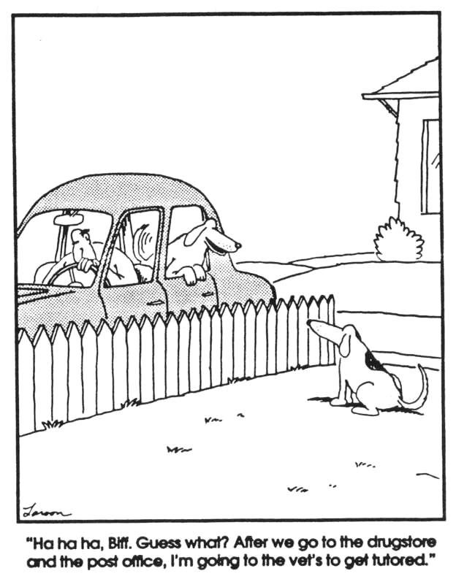

Job Description

POSITION: Peer Tutor

Though there are a variety of duties that a Peer Tutor must perform, the general purpose of the Peer Tutoring Program is to help students succeed in college. For the most part this involves providing academic assistance. Beyond this Peer Tutors must be knowledgeable about academic policies and procedures, as well as the various support services available to WVSC students. The following is a list of duties:

1. Follow the policies and procedures of the Peer Tutoring Program.
2. Check your mail folder every time you meet with students.
3. Meet with students at the times scheduled and for the entire time scheduled.
4. Accurately maintain all required reports and documentation and submit these as requested and in a timely manner.
5. Help students succeed in school, including help with doing subject review and practice, managing study time, preparing for exams, and taking notes.
6. Insure that the student, not you, does the required class work.
7. Make appropriate referrals to faculty or support staff when a student needs services that you are unable or unqualified to provide.
8. Practice the ethical standards of helping paraprofessionals, which include maintaining confidentiality with each of your students.
9. Regularly give students encouragement and realistic assessments of their efforts.
10. Practice courtesy with others using the Tutoring Room and take responsibility for keeping the Tutoring Room neat.
11. Meet with the Academic Assistance Counselor whenever a question or problem arises.
12. Perform other related duties as assigned.

Faculty/Staff Recommendation

The following student has applied for a tutoring position in the Peer Tutoring program through Counseling & Academic Support Services at West Virginia State University.

Name: _______________________________________________________________________
They will be tutoring (Please list course): ____________________________________________
Please check the appropriate block and make any comments you think would be helpful as we evaluate the student's candidacy for this position.
I recommend the student without hesitation

I recommend the student

I do not recommend the student

Please explain why you would recommend this student: ________________________________
_____________________________________________________________________________
_____________________________________________________________________________

Please print your name: _________________________________________________________

Title: _________________________________________________________________________

Signature: __________________________________________ Date: _____________________

Relationship to student __________________________________________________________

Note: The individual making the recommendation must have knowledge of the applicant's ability to provide the service. If you have any questions please feel free to contact me at dsquirts@wvstateu.edu or 304-766-3041.

Return to Daisy Squirts, Academic Assistance Counselor in 117 Sullivan Hall, East
Thank you for your assistance.

❖ Student Sign-in 
Tutor:
Work Period

Date | Student Name | Class | Time In | Time Out
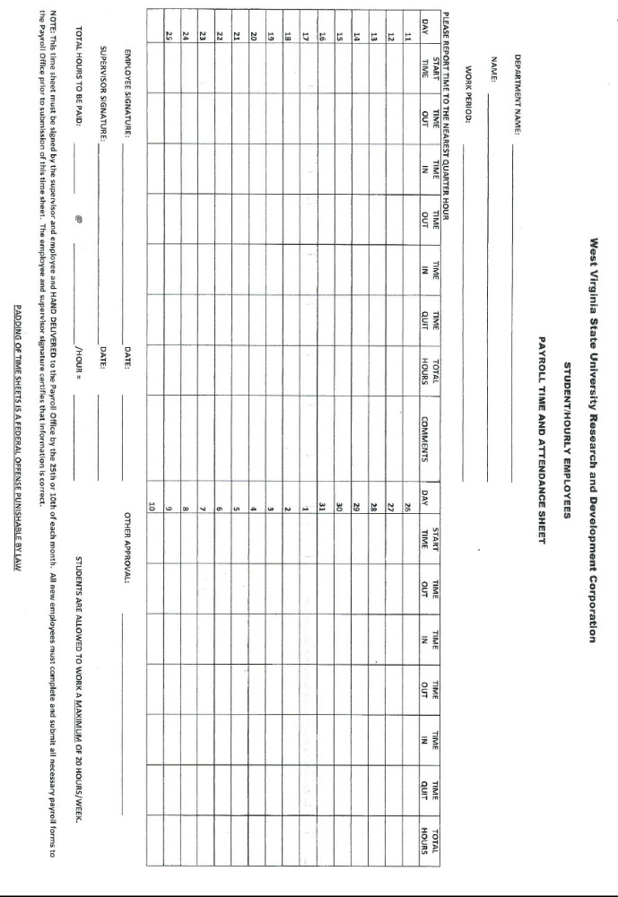

West Virginia State University
Counseling & Academic Support Services

Policies, Conduct, and Employee Confidentiality Statement

I, ____________________________ do certify that I have read and agree to follow all guidelines stipulated in the above Tutoring Handbook that includes all polices and codes of conduct. As an employee of the WVSU Counseling & Academic Support Services, I understand that I may have access to confidential information such as grades, student records, test results, student progress in class, and similar data. I am aware that I may receive verbal or written communication with my supervisor, course instructor, or other students concerning course grades, which should be kept confidential. I also understand that employment with Counseling & Academic Support Services means I must accept responsibility to preserve the confidentiality of this information and that failure to adhere to these guidelines may result in the termination of my employment.

_____________________________ ______________________________
Tutor Signature Date Witness Signature Date

WVSU Counseling & Academic Support Services
Peer Tutor Training Evaluation

Please take a few moments to evaluate the Peer Tutor Training so that we may improve the quality of service.

1. Did you receive sufficient information about the Peer Tutor Training?
Yes ___ No ___

2. Was the event organized? Yes ___ No ___

3. Were all your questions answered in a satisfactory manner?
Yes ___ No ___

4. Was this a beneficial experience for you? Yes ___ No ___

Why?____________________________________________________________________

As a Peer Tutor, what would you suggest as an improvement to our training session?
___________________________________________________________________________________________________________________________________________________________________________

What would you suggest as an improvement to our Peer Tutoring Program?
___________________________________________________________________________________________________________________________________________________________________________

Comments:
___________________________________________________________________________________________________________________________________________________________________________

* From We’re Born to Learn, by Rita Smilkstein. Corwin Press, Inc. 2003.
*From The Master Tutor, by R.B. MacDonald, Stratford Study Skills Institute, 1994.

