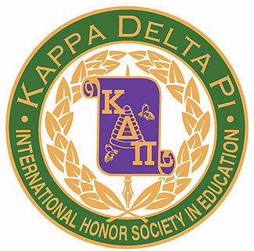

Kappa Delta Pi is an International Honor Society in Education. The Lambda Zeta Chapter at West Virginia State University is one chapter amongst hundreds across the world. Lambda Zeta has earned three “Achieving Chapter Excellence” awards presented to officers at the international conferences.
The members of the Lambda Zeta Chapter sponsor professional development programs for education students and conduct community service projects. Examples of some of these projects include the annual Mitten Tree where members collect hats, scarves and gloves for students of low socio-economic backgrounds, Parent’s Night Out where members provide an evening of childcare for children with special needs, and Literacy Alive where funds collected from the annual Scholastic Book Fair are used to purchase books for a local school.
The Kappa Delta Pi words and creed: "So to TEACH that our words inspire a will to learn. So to SERVE that each day may enhance the growth of exploring minds. So to LIVE that we may guide young and old to know the truth and love the right."

